A Major Project Report
On

AI STOCK ADVISOR

&

QUANTUM PORTFOLIO OPTIMIZER
Submitted in partial fulfilment for the Degree of B. Tech.
In
Information Technology
By
I. Shravya [22911A1288]
J. Yogesh kumar[22911A1278]
K. Prathibha [22911A1292]
K. Sindhu [22911A1294]

Under the guidance of

Mrs. Deepthi Reddy
Assistant Professor – Department of IT



DEPARTMENT OF INFORMATION TECHNOLOGY
VIDYA JYOTHI INSTITUTE OF TECHNOLOGY
(An Autonomous Institution)
[Accredited by NAAC & NBA, Approved by AICTE New Delhi &
Permanently Affiliated to JNTUH]

2025 – 2026



CERTIFICATE

This is to certify that the project report entitled “AI STOCK ADVISOR AND QUANTUM PORTFOLIO OPTIMIZER” submitted by I.Shravya [22911A1288], J.Yogesh [22911A1289], K.Sindhu [22911A1292], K.Prathibha[22911A1294] to Vidya Jyothi Institute of Technology (An Autonomous Institution), Hyderabad, in partial fulfilment for the award of the degree of B. Tech. in Information Technology a Bonafide record of project work carried out by us under my supervision. The contents of this report, in full or in parts, have not been submitted to any other Institution or University for the award of any degree.

Signature of Supervisor
Mrs. Deepthi Reddy
Assistant Professor
Department of Information Technology
Signature of Head of the Department Dr.A.Obulesu
Professor
Department of Information Technology

Signature of External Examiner

DECLARATION

We declare that this project report titled AI Stock Advisor and Quantum Portfolio Optimizer submitted in fulfilment of the degree of B. Tech. in Information Technology is a record of original work carried out by us under the supervision of Mrs. Deepthi Reddy, and has not formed the basis for the award of any other degree or diploma, in this or any other Institution or University. In keeping with the ethical practice of reporting scientific information, due acknowledgements have been made wherever the findings of others have been cited.

I. Shravya [22911A1288]
J. Yogesh kumar 22911A1289]
K. Prathibha [22911A1292]
K. Sindhu [22911A1294]

Date:

ACKNOWLEDGEMENTS

We extend our heartfelt gratitude to Mrs. Deepthi Reddy, Assistant Professor, for his invaluable mentorship and guidance throughout the course of this project. His expertise, encouragement, and insightful feedback played a crucial role in shaping our approach and refining our methodology.
We are deeply grateful to Dr. A. Obulesu, Head of the Department, and all the faculty members of the department for their constant support and guidance throughout our academic journey.
Our sincere thanks to our beloved Dean of Accreditation and Rankings, Dr. A. Padmaja Madam, and Academic Co-originator, Smt. G. Srilatha Madam, whose unwavering support proved indispensable during the course.
We also express our heartfelt thanks to our Principal, Dr. A. Srujana madam, for her encouragement and continuous support throughout this endeavour.
We would like to sincerely thank our College Management for providing the necessary infrastructure and facilities that enabled us to carry out our work effectively.
We are thankful to our friends, well-wishers, for their valuable suggestions and constant willingness to help, which motivated us to give our best throughout this journey.
Finally, we would like to express our deepest gratitude to our Parents, whose unwavering love, guidance, and support have been the foundation of our success and aspirations.

I. Shravya [22911A1288]
J. Yogesh kumar 22911A1289]
K. Prathibha [22911A1292]
K. Sindhu [22911A1294]

INDEX

S.No. | Topic | Page No.
 | Abstract | i
1. Introduction
1.1 | Introduction | 1
1.2 | Problem Description | 2
1.3 | Existing System | 2
1.4 | Proposed System | 4
2. Literature Survey
2.1 | Related Work | 6
2.2 | Research Gap | 9
3. Problem Statement & Objectives
3.1 | Problem Statements | 13
3.2 | Objectives | 13
4. Methodology
4.1 | Methodology | 15
5. System Analysis
5.1 | Software Requirement Specifications | 18
5.2 | Software & Hardware Requirements | 20
6. System Architecture
6.1 | System Architecture | 22
6.2 | Algorithm | 26
7. Implementation Details
7.1 | Backend Implementation Fast-API | 40
7.2 | Stock Overview Module | 43
7.3 | Fundamental Analysis Module | 47
7.4 | Technical Analysis | 52
7.5 | Price Prediction Module | 59
7.6 | Quantum portfolio Optimization Module | 67
7.7 | Frontend Implementation | 73
8. Results and Discussion
8.1 | Overview Module | 88
8.2 | Fundamental Analysis | 90
8.3 | Technical Analysis | 91
8.4 | Forecasting Module | 94
8.5 | Quantum Portfolio Optimization | 96
8.6 | Quantum Portfolio Optimization | 99
8.7 | Discussion Summary | 100
9. Comparison Analysis
9.1 | Comparison Analysis | 101
10. Conclusion and Future Scope
10.1 | Conclusion | 105
10.2 | Future Scope | 107
11. References |  | 111

ABSTRACT

The stock market is a dynamic financial environment where investors must analyze large amounts of financial data before making investment decisions. However, many investors lack the technical and financial knowledge required to interpret company performance, price movements, and market risk. Manual analysis of financial statements and price charts is time-consuming and often leads to inaccurate or emotional decisions. To address this problem, the project “AI Stock Advisor and Quantum Portfolio Optimizer” is developed as an intelligent decision-support platform that assists users in analyzing stocks using automated financial and technical analysis.

The system retrieves real-time and historical stock market data using financial APIs [1] and processes it through multiple analytical modules. The Stock Overview and Fundamental Analysis modules evaluate company performance using indicators such as Market Capitalization, Price-to-Earnings Ratio (P/E), Return on Equity (ROE), and Debt-to-Equity Ratio. In addition, the system introduces a Management Credibility Score (MCS) within the Fundamental Analysis module, which assesses the reliability of company management by comparing promised financial growth with actual reported performance. This helps in identifying trustworthy companies and improves decision-making. The Technical Analysis module studies price trends and momentum using indicators such as Moving Averages, Relative Strength Index (RSI), MACD, and Bollinger Bands. In addition, the Prediction module generates future price scenarios (Bull, Base, and Bear cases) based on historical growth and volatility patterns to help investors understand possible market outcomes.

To support risk management and diversification, the system includes a quantum-inspired portfolio optimization module. The portfolio selection problem is modeled using risk measures such as Conditional Value at Risk (CVaR) [2], liquidity risk [3], and drawdown, and optimized using the Quantum Approximate Optimization Algorithm (QAOA) on a simulator. The final results are presented through an interactive web dashboard [4, 5] that displays charts, financial metrics, forecasts, and stock recommendations. The proposed system simplifies complex stock market analysis and acts as a comprehensive advisory tool that helps investors make informed and rational investment decisions.

LIST OF FIGURES

S.No | Title | Page No.
Figure 6.1.1 | System Architecture | 22
Figure 8.1.1 | Over view module | 88
Figure 8.1.2 | Over view module | 89
Figure 8.2.1 | Fundamental Analysis | 90
Figure 8.2.2 | Fundamental Analysis | 90
Figure 8.3.1 | Fundamental Analysis Chart | 91
Figure 8.3.2 | Technical Summary | 92
Figure 8.3.3 | Price Action, SMA 200, SMA 50 & Bollinger bands Chart | 93
Figure 8.3.4 | RSI & MACD Indicators | 93
Figure 8.3.5 | ATR & ROC 12 Indicators | 94
Figure 8.4.1 | 5-Year Trajectory Fan Chart | 94
Figure 8.4.2 | Forecast Summary | 95
Figure 8.5.1 | Portfolio Allocation | 96
Figure 8.5.2 | Monte Carlo Engine and Diversification Matrix | 97
Figure 8.5.3 | Component Risk analysis | 98

LIST OF TABLES

S.No | Name Of The Table | Page No.
Table 2.1.1 | Literature Survey | 10
Table 2.1.1 | Literature Survey | 11
Table 7.1 | API Endpoints Summary | 43
Table 7.3.1.1 | Scoring Methodology and Weighting Logic | 49
Table 8.6.1 | Quantum Portfolio Optimization Results | 99
Table 9.1.1 | Existing System vs Proposed System Comparison | 103

INTRODUCTION

Introduction:

The stock market is one of the most significant financial systems in the modern economy, providing opportunities for individuals and institutions to invest and generate wealth. Investors purchase shares of companies with the expectation of earning profit through price appreciation and dividends. However, stock prices are highly dynamic and influenced by several factors such as company financial performance, economic conditions, political events, global markets, and investor sentiment. Due to this complexity, making correct investment decisions is difficult, particularly for beginner investors who lack financial and analytical expertise.
Traditionally, investors rely on financial news, brokerage advice, or manual chart analysis to select stocks. These approaches are often unreliable because they depend heavily on human interpretation and incomplete information. Understanding company financial statements, analyzing price charts, and evaluating market risk requires significant knowledge and experience. As a result, many investors make emotional or speculative decisions, which may lead to financial losses and poor portfolio planning.
In recent years, data analytics and intelligent computational systems have been applied in financial markets to automate analysis and improve decision-making [6]. By using real-time market data [1] and mathematical indicators, a system can analyze company performance, detect trends, and provide meaningful insights. The proposed project “AI Stock Advisor and Quantum Portfolio Optimizer” is developed as an intelligent financial decision-support platform. The system integrates stock overview, fundamental analysis, technical analysis, price forecasting, and portfolio optimization into a single application to help users understand stock behavior and make informed investment choices.
The system evaluates company strength using financial metrics and analyzes market trends using technical indicators. The Fundamental Analysis module also includes a Management Credibility Score (MCS), which compares promised and actual performance to assess management reliability. A quantum-inspired portfolio optimization module [7] is used to select an optimal combination of stocks [8] based on risk factors [2, 3]. he platform presents results through an interactive dashboard for easy understanding and better investment decisions.

Problem description:
Investing in the stock market requires careful analysis of company performance, market trends, volatility, and diversification. However, many investors lack the knowledge required to interpret financial ratios, price charts, and technical indicators. Existing trading platforms mainly provide raw information such as stock prices and financial reports, but they do not guide investors on how to analyze the data.
Another major issue is risk management. Investors often select stocks randomly or based on recommendations without understanding diversification principles, which increases risk and may lead to financial loss. Furthermore, predicting stock price movement is difficult due to the nonlinear and volatile nature of financial markets [6].
Most available systems focus only on either financial ratios or price prediction and fail to integrate multiple analysis methods into a single platform. They also lack mechanisms for risk-based portfolio optimization [8]. In addition, existing systems do not evaluate management reliability, which plays a crucial role in long-term investment decisions.
Retail investors often depend on social media tips, rumors, or emotional decisions, increasing uncertainty and investment risk. Manual analysis is time-consuming and prone to errors. Hence, there is a strong need for an intelligent advisory system that provides integrated analysis, evaluates management credibility, reduces decision complexity, and supports reliable investment planning.

Existing System:

Current stock analysis platforms mainly provide stock price charts, company financial statements, and market news. Investors must manually interpret this information to make investment decisions. These systems commonly rely on technical charts and historical data visualization but do not provide meaningful investment guidance. As a result, users receive information but not proper advice.
Some platforms include basic indicators such as moving averages or volume analysis. However, they still require strong financial knowledge to interpret signals correctly. Most systems also focus only on either company fundamentals or price movements separately, and very few systems integrate both aspects together. In addition, they do not analyze market risk or uncertainty while suggesting investments [2, 3].
Existing platforms also fail to provide personalized assistance for investors. They present large amounts of financial data, which can confuse beginner users. There is no automatic mechanism to evaluate whether a stock is overvalued or undervalued, and users must depend on their own understanding. Moreover, forecasting future price behavior is either missing or limited to simple trend projections.
Another important limitation is that existing systems do not evaluate the credibility of company management. They rely only on financial data and ignore whether companies actually deliver on their promised performance. This lack of management credibility assessment can lead to misleading investment decisions, especially in long-term investments.

Drawbacks:

- Lack of Decision Support
Existing systems mainly act as information providers rather than decision-support tools. They display stock prices, charts, and financial reports, but they do not clearly tell the investor whether the stock is a good investment or not. Users must independently analyze the data and draw conclusions, which often leads to confusion and incorrect interpretation, especially for beginners.
- Requires Financial Knowledge
Most platforms assume that the user understands financial statements and technical indicators. Interpreting candlestick patterns, moving averages, RSI signals, or financial ratios requires experience in stock market analysis. New investors find it difficult to understand these concepts and may make wrong decisions due to lack of knowledge.
- No Integrated Analysis
Current systems do not combine fundamental analysis, technical analysis, and price forecasting together. Investors need to visit multiple websites or tools to gather complete information about a single stock. Because the analysis is scattered, users cannot easily compare results, which increases complexity and reduces decision accuracy.
- No Portfolio Optimization
Existing platforms focus only on individual stock analysis and do not help in building a balanced portfolio. They do not consider diversification, risk distribution, or asset allocation [8]. As a result, investors may unknowingly invest heavily in similar types of stocks, increasing overall portfolio risk.
- No Management Credibility Evaluation
Existing systems do not analyze whether company management fulfills its financial promises. They ignore the gap between projected and actual performance, which is a critical factor in evaluating long-term investment reliability. Without this, investors may trust companies with poor execution history, increasing financial risk.

Proposed System:

The proposed system introduces an intelligent investment decision-support platform called AI Stock Advisor and Quantum Portfolio Optimizer to overcome the limitations of traditional stock analysis platforms. The system uses real-time and historical stock market data collected from financial APIs (Yahoo Finance) [1] as input and applies data preprocessing techniques such as data validation, cleaning, and normalization to ensure reliable and consistent information. The platform analyzes stock data and assists investors in making informed investment decisions instead of relying on speculation.
he system performs fundamental analysis by evaluating important financial ratios such as Market Capitalization, Price-to-Earnings Ratio (P/E), Return on Equity (ROE), and Debt-to-Equity Ratio to measure company financial strength. In addition, the system integrates a Management Credibility Score (MCS) within the Fundamental Analysis module, which evaluates the reliability of company management by comparing promised financial performance with actual reported results. This helps identify trustworthy companies and enhances long-term investment decision-making. In addition, technical analysis is carried out using indicators like Moving Averages (SMA-50 & SMA-200), Relative Strength Index (RSI), MACD, and Bollinger Bands to understand market trends, momentum, and volatility patterns
To further support investors, the system implements a forecasting module that estimates future stock behaviour using historical growth and volatility. Instead of providing a single uncertain prediction, the system generates three possible market scenarios — Bull Case, Base Case, and Bear Case — allowing users to understand future price possibilities and associated risk.
To improve investment reliability, the proposed system incorporates a quantum-inspired portfolio optimization module. Selected stocks are converted into an optimization problem using a Quadratic Unconstrained Binary Optimization (QUBO) formulation. The Quantum Approximate Optimization Algorithm (QAOA) is executed on a simulator to select an optimal combination of stocks that balances diversification and risk reduction using measures such as Conditional Value at Risk (CVaR) [2].
Finally, the platform presents all results through an interactive dashboard [4, 5] containing stock charts, financial metrics, technical indicators, predictions, and recommendations. This helps investors make rational, data-driven decisions rather than emotional trading decisions.

Advantages:

- Integrated Multi-Analysis Platform
Platform combines fundamental analysis, technical indicators, prediction, and portfolio optimization in a single application. Users no longer need to visit multiple financial websites or tools to analyze a stock. This integrated approach saves time and offers a complete evaluation of investment opportunities.

- Risk-Aware Portfolio Selection
The quantum portfolio optimization module selects a balanced combination of stocks to minimize overall investment risk. It considers diversification and avoids highly volatile stock selections. As a result, the portfolio becomes more stable and suitable for long-term investment planning.

- Beginner-Friendly Decision Support
The dashboard presents financial metrics, charts, and recommendation ratings in a simple visual format. Even users without strong financial knowledge can easily understand the analysis results. This makes the system accessible for students, new investors, and non-technical users.
- Data-Driven Decision Making
All recommendations are generated using real-time market data, historical price trends, and calculated indicators. The system reduces emotional or rumor-based trading decisions. Investors can rely on logical, data-supported insights before investing.

- Real-Time Data Driven Analysis
The system uses live market data fetched from Yahoo Finance APIs, ensuring that all analysis and recommendations are based on the most recent stock prices and financial information.

- Management Credibility Evaluation
The system includes a Management Credibility Score (MCS) that evaluates whether companies deliver on their promised financial performance. By comparing projected and actual results, the system helps investors identify trustworthy companies and avoid unreliable ones, improving long-term investment reliability.

LITERATURE SURVEY

2.1 Related Work
Stock market prediction and portfolio recommendation have been widely studied in the fields of financial analytics, machine learning, and artificial intelligence. Many researchers have attempted to develop systems that analyze historical stock data, technical indicators, and company financial metrics to forecast stock price movements and assist investors in decision-making. However, due to the highly volatile and nonlinear nature of financial markets, accurate prediction remains a challenging task.

1. Optimization of Conditional Value-at-Risk
Authors: R. Tyrrell Rockafellar, Stanislav Uryasev
Year: 2000
Description:
This paper introduces the optimization of Conditional Value at Risk (CVaR) to address the mathematical flaws of using standard variance as the primary proxy for financial risk. The research focuses on calculating the average expected loss strictly within a defined worst-case percentile, such as the worst 5% of trading days, to properly evaluate severe downside market exposure.
The study successfully demonstrates that CVaR is a coherent risk measure that accurately captures the severity of extreme tail-end market crashes. It provides a vastly superior metric for institutional risk management compared to traditional variance, offering a more realistic framework for preserving capital during severe market downturns and flash crashes.
Limitations:
- Computationally expensive for large, discrete asset universes
- Transforms into a complex Mixed-Integer Linear Programming (MILP) problem
- Classical heuristic solvers frequently become trapped in local minima
- Lacks a framework for real-time execution in dynamic financial environments

2. A Quantum Approximate Optimization Algorithm
Authors: Edward Farhi, Jeffrey Goldstone, Sam Gutmann
Year: 2014
Description:
This paper introduces the Quantum Approximate Optimization Algorithm (QAOA), a revolutionary hybrid quantum-classical algorithm designed specifically to run on noisy intermediate-scale quantum (NISQ) devices. The research outlines how complex combinatorial optimization problems can be mathematically mapped onto quantum physical systems using Ising Hamiltonians to evaluate vast solution spaces.
The authors establish a variational approach where a quantum circuit alternates between a Problem Hamiltonian and a Mixing Hamiltonian. By iteratively tuning the parameters of these layers using a classical optimizer, the study demonstrates that the algorithm smoothly converges toward a near-optimal solution, theoretically outperforming classical approximation algorithms for NP-hard combinatorial problems.

Limitations:
- Remains strictly theoretical and heavily abstracted in quantum physics
- Relies on generic mathematical graphs rather than live data environments
- Lacks an architectural framework for practical financial implementations
- Provides no guidance on decoding quantum states into human-readable interfaces

3. Quantum Bridge Analytics I: A Tutorial on Formulating and Using QUBO Models
Authors: Fred Glover, Gary Kochenberger, Yu Du
Year: 2019
Description:
This paper presents the Quadratic Unconstrained Binary Optimization (QUBO) model as a powerful framework for solving complex optimization problems. It explains how real-world problems, including financial portfolio selection, can be represented using binary decision variables and mathematical formulations.
The study highlights that QUBO models can be efficiently integrated with quantum algorithms such as QAOA to solve large-scale optimization problems. This makes QUBO a suitable approach for handling complex financial decision-making tasks like portfolio optimization.

Limitations:
- Difficult to formulate for complex real-world scenarios
- High computational cost for large datasets
- Requires proper parameter tuning
- Not all financial problems fit naturally into QUBO

4 A Survey on Machine Learning for Stock Price Prediction: Algorithms and Techniques
Authors: Román Orús, Samuel Mugel, Enrique Lizaso
Year: 2019
Description:
This paper provides an overview of the applications of quantum computing in financial systems, including portfolio optimization, risk analysis, and financial modeling. It explains how quantum techniques can be used to handle complex financial computations more effectively than traditional methods.
The study highlights that quantum approaches have the potential to significantly improve the efficiency of solving high-dimensional financial problems. This makes them suitable for advanced financial applications where classical algorithms face limitations.

Limitations:
- Quantum computing is still in early development
- Limited practical implementation
- Requires specialized hardware
- High cost and complexity

5. 60 Years of Portfolio Optimization: Practical Challenges and Current Trends
Authors: S. Kolm, R. Tütüncü, C. Fabozzi
Year: 2014
Description:
This paper reviews the evolution of portfolio optimization techniques and explains how these methods have developed over time. It discusses the challenges faced in real-world financial applications, particularly in handling risk, uncertainty, and changing market conditions.
The study highlights the limitations of traditional portfolio models and emphasizes the need for advanced optimization approaches. It supports the use of improved and modern techniques to build more efficient and reliable financial decision-making systems.
Limitations:
- Focuses more on theoretical review than implementation
- Does not provide a unified optimization solution
- Limited integration with AI and quantum techniques
- Requires further development for real-time applications

2.2 Research Gap
Although many studies have explored stock price prediction using machine learning and deep learning techniques, several research gaps still exist. Most existing systems focus only on prediction and do not provide complete decision support by integrating fundamental analysis, technical analysis, and portfolio optimization. They also lack proper risk management using measures such as CVaR and do not consider real-time market uncertainty. In addition, existing approaches ignore management credibility, which is important for evaluating whether companies deliver on their financial promises. Furthermore, limited research has been done on applying quantum optimization techniques such as QAOA and QUBO in financial portfolio selection. Therefore, there is a need for an integrated system that combines multi-level analysis, risk-aware optimization, and credibility evaluation to support better investment decisions.

Ref No | Paper Citation (Title, Authors, Year) | Methodology / Algorithms Used | Dataset / Tools | Findings/ Results | Limitations
1. | Optimization of Conditional Value-at-Risk  R. T. Rockafellar, S. Uryasev (2000) | Conditional Value at Risk (CVaR), Expected Shortfall, Linear Programming | Historical portfolio return distributions, mathematical models | CVaR accurately captures extreme downside risk and is more effective than variance for risk management | Computationally expensive for large portfolios; complex optimization; not suitable for real-time systems
2 | A Quantum Approximate Optimization Algorithm  E. Farhi, J. Goldstone, S. Gutmann (2014) | QAOA, Alternating Operator Ansatz, Quantum circuits | Quantum simulators, classical optimizers | Efficiently solves combinatorial optimization problems using quantum superposition | Theoretical model; limited real-world use; requires quantum hardware
3 | Quantum Bridge Analytics I: QUBO Models  F. Glover, G. Kochenberger, Y. Du (2019) | QUBO formulation, Binary optimization | Mathematical models, optimization frameworks | Enables transformation of complex problems into solvable optimization models | Difficult formulation; high computational cost; requires tuning

4 | Quantum Computing for Finance: Overview and Prospects  R. Orús, S. Mugel, E. Lizaso (2019) | Quantum algorithms for finance, optimization models | Financial datasets, quantum frameworks | Quantum computing improves efficiency in solving complex financial problems | Early-stage technology; limited implementation; high cost
5 | 60 Years of Portfolio Optimization: Practical Challenges and Current Trends  S. Kolm, R. Tütüncü, C. Fabozzi (2014) | Portfolio optimization techniques, risk-return models | Financial datasets, historical analysis | Highlights limitations of traditional models and need for advanced techniques | Mostly theoretical; lacks real-time application; limited AI/quantum integration

Table 2.1.1: Literature Survey
Research Gaps
1. Lack of Integrated Analysis
Most existing research studies focus only on either technical analysis or prediction models. They do not combine fundamental analysis, technical indicators, forecasting, and management credibility evaluation into a single decision-making platform, which limits overall analysis effectiveness
2. No Risk-Aware Portfolio Selection
Existing systems mainly predict individual stock prices but do not help investors construct an optimal portfolio. They lack advanced risk management techniques such as Conditional Value at Risk (CVaR) and do not ensure proper diversification, leading to higher investment risk.
3. Limited Real-Time Data Usage
Many research models rely on static historical datasets and do not incorporate real-time market data. However, stock markets are highly dynamic, and effective decision-making requires continuous data updates and real-time analysis.
4. Absence of Quantum Optimization
Most stock prediction and portfolio models rely on classical optimization methods. Very few studies explore quantum optimization approaches such as QAOA and QUBO, which can efficiently solve complex combinatorial portfolio selection problems.

5. Lack of Decision Support
Existing systems act primarily as prediction tools and do not provide actionable recommendations such as buy, hold, or avoid. Additionally, they do not evaluate management credibility by comparing promised and actual performance, which is crucial for reliable long-term investment decisions.

PROBLEM STATEMENT & OBJECTIVES

PROBLEM STATEMENT

The stock market is one of the most dynamic and unpredictable financial environments, where investment decisions are influenced by multiple factors such as company performance, economic conditions, market trends, and investor sentiment. Investors, especially beginners, often face difficulty in analyzing stocks and selecting suitable investments due to the complexity and large volume of financial data. Incorrect decisions frequently occur because investors rely on speculation, rumors, or emotional behavior instead of proper analytical methods, which increases the risk of financial loss.

Although several stock analysis platforms and trading applications are available, most of them primarily provide stock price charts, financial statements, and market news. These systems require users to manually interpret technical indicators and company financial ratios. As a result, effective investment decisions demand strong financial knowledge and market experience. Beginners and non-technical users find it challenging to understand market behavior, evaluate company performance, and assess investment risk using these tools.

Existing approaches also fail to provide an integrated decision-support mechanism. Fundamental analysis, technical analysis, forecasting, and risk-aware portfolio construction are usually handled separately, and investors must analyze each aspect individually. Furthermore, most systems focus only on price prediction and do not assist users in selecting a diversified portfolio. The absence of portfolio optimization leads to higher investment risk and poor diversification.

In addition, existing systems do not evaluate management credibility, which is an important factor in long-term investment decisions. They fail to analyze whether companies deliver on their promised financial performance, which may lead to misleading investment choices.

Objectives

This project aims to develop an intelligent stock analysis and advisory platform that integrates real-time market data analysis with advanced analytical techniques and quantum-based portfolio optimization. The proposed system focuses on improving investment decision-making by combining financial evaluation, trend analysis, price forecasting, risk-aware portfolio selection, and management credibility assessment within a single unified framework.

Key Objectives

- To design and implement a stock advisory platform that retrieves real-time and historical stock market data using financial data APIs
- To perform fundamental analysis by evaluating company financial indicators such as Market Capitalization, Price-to-Earnings Ratio, Return on Equity, and Debt-to-Equity Ratio in order to assess company strength and stability.
- To incorporate a Management Credibility Score (MCS) within the fundamental analysis module to evaluate whether companies fulfill their financial promises by comparing projected and actual performance.
- To analyze stock market trends using technical indicators including Moving Averages, Relative Strength Index (RSI), Moving Average Convergence Divergence (MACD), Bollinger Bands, and volatility measures.
- To generate future price scenarios (Bull Case, Base Case, and Bear Case) using historical growth rates and volatility-based forecasting methods.
- To provide investment recommendations such as Strong Buy, Buy, Hold, or Avoid based on combined analysis results.
- To minimize portfolio risk and improve diversification by formulating the portfolio selection problem as a Quadratic Unconstrained Binary Optimization (QUBO) model.
- To present all analysis results through an interactive dashboard that displays charts, scores, forecasts, and recommendations for easy understanding.

- METHODOLOGY

Methodology

The The proposed methodology follows a structured workflow beginning with real-time stock data acquisition and preprocessing, followed by financial analysis, technical analysis, price forecasting, management credibility evaluation and quantum-based portfolio optimization. The system integrates multiple analytical modules to assist users in understanding stock performance and selecting a diversified investment portfolio. Finally, the results are visualized through an interactive dashboard for decision support.

Step 1: Data Acquisition
The first step involves collecting real-time and historical stock market data using financial data APIs (Yahoo Finance) [1]. The user provides an NSE stock symbol (such as TCS, INFY, or RELIANCE), which acts as the primary input for the system.
The retrieved data includes:
- Daily stock prices (Open, High, Low, Close)
- Trading volume
- Company financial information
- Market performance metrics
This data forms the foundation for further analysis and prediction processes.

Step 2: Data Preprocessing
In this stage, the collected stock data is prepared for analysis. The system validates the input stock symbol and checks whether the data is available. Missing values, null records, and inconsistent entries are handled to avoid computational errors.
The data is then:
- Cleaned and formatted
- Sorted according to date
- Converted into structured tabular form (DataFrame)
- Normalized for accurate calculations
The processed dataset becomes suitable for performing financial and technical analysis.

Step 3: Fundamental Analysis Module Implementation
The system evaluates the financial strength of the company using fundamental financial metrics. Key ratios extracted include:
- Market Capitalization
- Price-to-Earnings (P/E) Ratio
- Return on Equity (ROE)
- Debt-to-Equity Ratio
Each metric is compared with predefined financial thresholds. A weighted scoring model calculates the company’s financial health score. Based on this score, the system generates an investment recommendation such as:
Strong Buy, Buy, Hold, or Avoid
This step helps investors understand the company’s long-term investment potential.

Step 4: Technical Analysis Module Implementation
The system performs technical analysis using historical price data to understand market trends and trading signals [6]. Various indicators are calculated, including:
- Simple Moving Averages (SMA 50 and SMA 200)
- Relative Strength Index (RSI)
- Moving Average Convergence Divergence (MACD)
- Bollinger Bands
- Momentum and volatility indicators
These indicators help identify trend direction, overbought and oversold conditions, and price fluctuations. The results are synchronized with price charts for visualization.

Step 5: Price Forecasting Module
The forecasting stage estimates possible future stock price movements. Instead of producing a single prediction, the system generates three possible scenarios:
- Bull Case (optimistic growth)
- Base Case (expected growth)
- Bear Case (pessimistic decline)
The prediction is calculated using:
- Historical CAGR (growth rate)
- Market volatility
- Valuation assumptions
Probability values are assigned to each scenario to reflect uncertainty in market behavior.
Step 6: Management Credibility Analysis
This module evaluates the reliability of company management by comparing promised financial performance with actual reported results. Historical financial statements and growth projections are analyzed to identify gaps between expected and achieved performance.
A Management Credibility Score (MCS) is calculated based on this comparison. Companies with consistent performance receive higher credibility scores, while inconsistent performers are penalized. This score is used to adjust investment recommendations and improve long-term decision-making reliability.

Step 7: Quantum Portfolio Optimization Module
After analysis, selected stocks are passed to the portfolio optimization module. The portfolio selection problem is formulated as a Quadratic Unconstrained Binary Optimization (QUBO) model.
The system applies the Quantum Approximate Optimization Algorithm (QAOA) [7] using a quantum simulator. The optimizer selects an optimal subset of stocks that:
- Minimizes investment risk [2] [3]
- Improves diversification [8]
- Maintains balanced asset allocation
This step provides a recommended portfolio rather than individual stock suggestions.

Step 8: Visualization and Recommendation
Finally, the results are displayed on an interactive dashboard. The dashboard [4] [5]presents:
- Stock price charts
- Financial ratios
- Technical indicator graphs
- Forecast scenarios
- Recommended portfolio allocation
The visualization helps users easily understand stock performance and make informed investment decisions without requiring deep financial expertise.

SYSTEM ANALYSIS

Software Requirement Specifications (SRS)

The Software Requirement Specification describes the functionalities and operational behavior of the proposed system. The system is designed as a web-based intelligent stock advisory platform that retrieves real-time market data, performs stock analysis, forecasts future trends, and recommends an optimized portfolio to the user.

5.1.1 Functional Requirements
• Stock Symbol Input
The system must allow the user to enter a valid NSE stock symbol (such as TCS, INFY, RELIANCE) and validate its availability before processing.

• Real-Time Data Retrieval
The system must fetch real-time and historical stock market data using financial data APIs. The retrieved data should include daily stock prices (Open, High, Low, Close), trading volume, and company financial information.

• Data Preprocessing
The system must clean and organize the collected data by handling missing values, incorrect entries, and formatting inconsistencies. The data should be converted into a structured format suitable for analysis.

• Fundamental Analysis
The system must evaluate company financial strength using financial ratios such as Market Capitalization, Price-to-Earnings (P/E) Ratio, Return on Equity (ROE), and Debt-to-Equity Ratio. Based on the calculated score, the system should generate investment recommendations like Strong Buy, Buy, Hold, or Avoid.

• Management Credibility Evaluation
The system must evaluate the reliability of company management by comparing promised financial performance with actual reported results. A Management Credibility Score (MCS) should be calculated and used to enhance investment decision-making and improve prediction reliability

• Technical Analysis
The system must compute technical indicators including Moving Averages (SMA 50 & SMA 200), Relative Strength Index (RSI), MACD, Bollinger Bands, and volatility indicators to identify market trends and trading signals.

• Forecasting Module
The system must generate future price scenarios (Bull Case, Base Case, and Bear Case) using historical growth rate and market volatility. Each scenario should represent possible future stock behavior.

• Quantum Portfolio Optimization
The system must construct an optimized portfolio by applying a quantum optimization algorithm (QAOA). It should select a combination of stocks that minimizes risk and improves diversification.

• Visualization and Dashboard
The system must display analysis results using an interactive dashboard including stock price charts, technical indicator graphs, financial metrics, forecasts, portfolio allocation, and investment recommendations.

5.1.2 Non-Functional Requirements

• Performance
The system should retrieve market data and perform analysis efficiently. The dashboard should load quickly, and analytical results should be generated within a reasonable time. The quantum optimization module may take slightly longer computation time but should still complete within acceptable limits.

• Accuracy
The system should provide accurate analysis results by correctly calculating financial ratios, technical indicators, and forecasting scenarios. The portfolio optimization should improve diversification and reduce investment risk.

• Reliability
The system should produce consistent outputs for the same stock data. It should handle API failures, missing data, and invalid symbols without crashing and continue functioning properly.

• Scalability
The system should support analysis of multiple stocks and future expansion. New indicators, prediction techniques, or optimization methods should be easily integrated without redesigning the system.

• Usability
The system interface should be simple and user-friendly. Even users without financial knowledge should be able to understand the charts, recommendations, and portfolio suggestions.

Software & Hardware Requirements:

5.2.1 Software Requirements
The following software tools and technologies are required for the development, execution, and deployment of the proposed AI Stock Advisor and Quantum Portfolio Optimizer system:
• Operating System:
Windows 10 / Linux / macOS
• Programming Language:
Python (Version 3.9 or above)
• Backend Framework:
FastAPI – For developing RESTful APIs and handling backend logic
• Frontend Technologies:
React.js – For building interactive user interfaces
Node.js – Runtime environment for frontend development
• Development Environment:
Visual Studio Code / PyCharm

Libraries and Frameworks:
o NumPy – For numerical computations and mathematical operations
o Pandas – For data handling, preprocessing, and tabular analysis
o yFinance API – For fetching real-time and historical stock market data
o Scikit-learn – For statistical calculations and evaluation utilities
o Qiskit – For implementing quantum portfolio optimization using QAOA on simulators
o Matplotlib / Chart.js / Recharts – For data visualization and chart rendering
o Uvicorn – ASGI server for running the FastAPI backend

5.2.2 Hardware Requirements
The following hardware configuration is required to run the system efficiently:
• Processor:
Intel i5 / AMD Ryzen 5 or higher
• RAM:
Minimum 8 GB (Recommended: 16 GB for quantum simulation)
• Storage:
Minimum 10 GB free disk space
• Internet Connection:
Required for fetching real-time stock market data from financial APIs
• System Type:
64-bit operating system

SYSTEM DESIGN

System Architecture

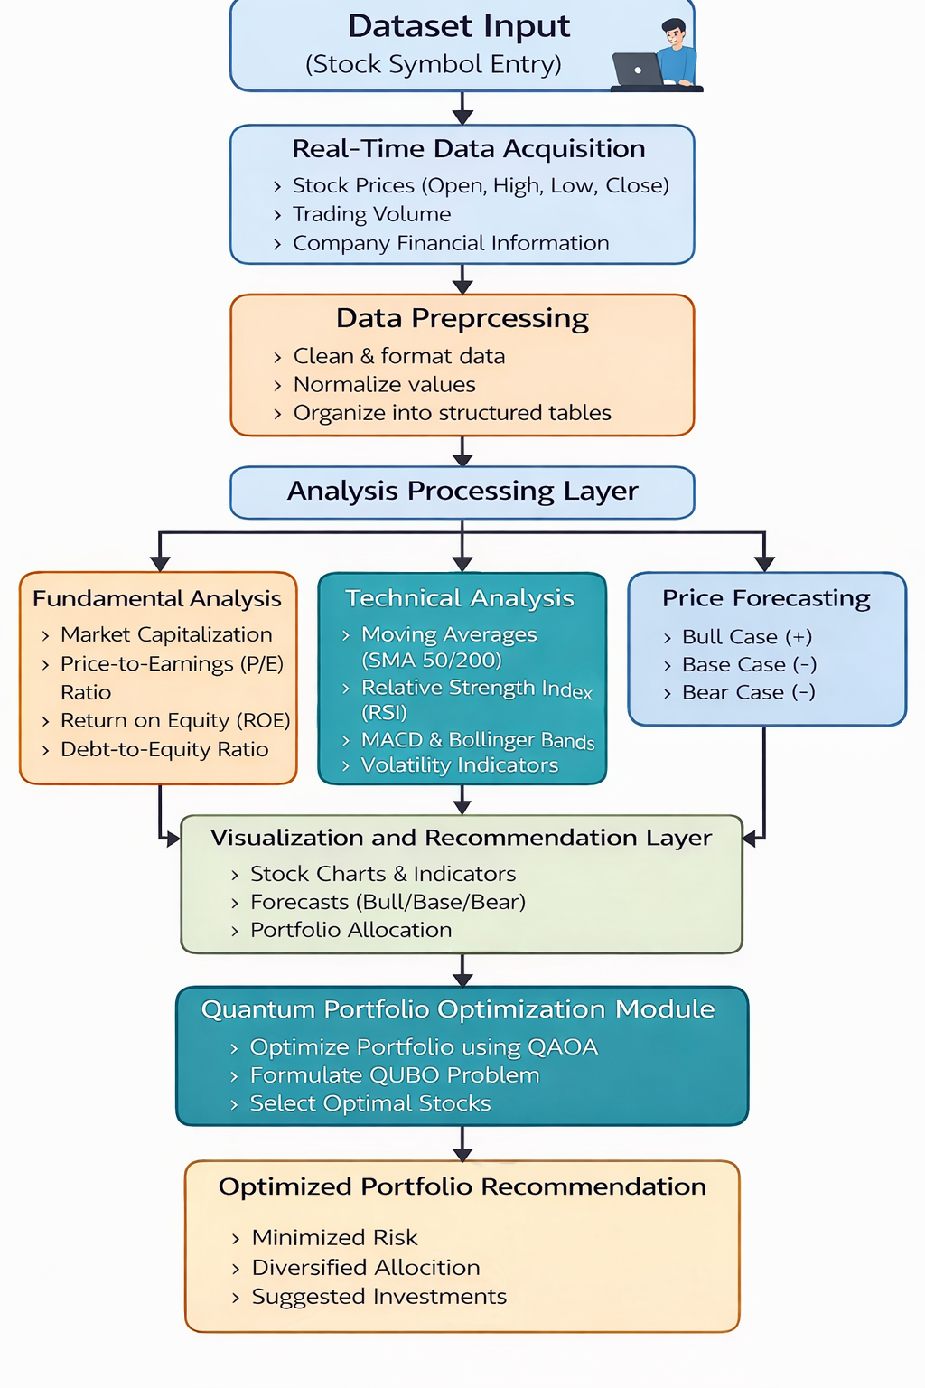
Figure 6.1.1: System Architecture

The above figure 6.1.1 describes the workflow of the AI Stock Advisor and Quantum Portfolio Optimizer, showing how data flows from user input to final analysis outputs and portfolio recommendation. The system integrates real-time market data, multi-level analysis (overview, fundamentals, technicals, forecasting), and a quantum-based portfolio optimization layer.The AI Stock Advisor and Quantum Portfolio Optimizer system follows a highly scalable, decoupled modern client–server architecture designed to deliver real-time financial analytics, complex technical indicators, and AI-based stochastic forecasting for Indian stock market equities. This architecture seamlessly integrates a highly responsive, institutional-grade frontend interface, a high-performance Python-based backend API, and external financial data ingestion pipelines to provide a robust, end-to-end quantitative analysis platform.
The architectural framework is logically divided into three major operational layers:
- Presentation Layer (Frontend): The interactive user interface built for data visualization and user inputs.
- Application Layer (Backend / API Services): The core computational engine handling routing, mathematical algorithms, and quantum simulations.
- Data Layer (Financial Data Sources): The external ingestion pipelines responsible for fetching live and historical market data.
These layers communicate exclusively through asynchronous RESTful APIs, enabling seamless, non-blocking interaction between the user interface and the heavy mathematical data processing components. The overarching goal of this decoupled architecture is to ensure immense scalability for large financial datasets, instantaneous real-time stock analytics, a modular design allowing for rapid future feature expansion, mathematically precise data visualization, and a strict separation of concerns between UI rendering and the core analytics engine.
6.1 System Architecture Detailed Breakdown
The system architecture is meticulously engineered to ingest raw financial data, execute complex quantitative and quantum-inspired algorithmic computations, and present highly actionable insights to users through an interactive, zero-latency dashboard. The architecture ensures a secure, efficient, and rapid data flow from external data providers all the way to the frontend SVG visualization components.
6.1.1 Frontend Layer (User Interface)
The frontend layer is developed as a modern Single Page Application (SPA) using React.js [4], which provides a highly efficient, component-based architecture for building fluid and interactive user interfaces. This presentation layer allows investors and quantitative analysts to effortlessly explore stock market data, perform deep technical analysis, and view AI-driven Monte Carlo predictions without experiencing page reloads. The frontend leverages Tailwind CSS for responsive, utility-first styling to achieve a premium "Cyber-Finance" dashboard layout. Data visualization is entirely driven by the Recharts library [5], converting complex arrays into readable graphical formats, while the React Context API is heavily utilized for seamless global state management.
In this project, the frontend layer acts as the interactive command center where the user initiates all analytical requests by entering an NSE stock ticker into the search component, which triggers a global state update via the React Context API. Once the state is updated, the frontend asynchronously dispatches multiple RESTful HTTP GET and POST requests to the FastAPI backend, awaiting the heavily computed JSON payloads without freezing the user interface. Upon receiving the processed data, the frontend utilizes the Recharts library to dynamically construct complex, interactive visualizations such as Dual Y-Axis Area charts for price action, overlapping stepped lines for fundamental convergence, and customized mathematical Treemaps for quantum portfolio allocations, all wrapped in a highly responsive Tailwind CSS grid layout that mimics an institutional Bloomberg terminal, completely eliminating the need for manual page reloads and ensuring a fluid, instantaneous user experience.
6.1.2 Backend Layer (Application Server)
The backend layer is implemented using FastAPI [1] [9], a modern, ultra-high-performance web framework for building RESTful APIs in Python 3.9+. The backend serves as the absolute core processing unit of the system, acting as the bridge between the user's requests and the heavy mathematical and quantum engines. FastAPI was explicitly selected for this architecture because of its native support for asynchronous request handling (ASGI), extreme execution speed, automatic OpenAPI documentation generation, and its flawless integration with Python’s dominant financial, data science (Pandas, NumPy), and quantum computing (Qiskit) libraries [10]. The backend exposes modularized API endpoints (e.g., /stock/overview, /stock/technicals, /quantum/optimize) to dynamically serve data based on precise user queries.
The backend layer operates as the central mathematical and routing engine of the platform, utilizing FastAPI to handle incoming asynchronous HTTP requests from the React frontend without blocking concurrent operations. When a request hits a specific endpoint, such as /stock/technicals/{ticker}, the backend router intercepts the call, invokes the external data ingestion functions to pull the required historical time-series data, and subsequently passes this raw data into our custom Python analytical scripts where powerful libraries like Pandas and NumPy perform heavy matrix operations to calculate indicators like MACD, RSI, and Bollinger Bands. Furthermore, for portfolio construction, the backend routes requests to the dedicated quantum module where risk metrics like Conditional Value at Risk (CVaR) are computed, formulated into a Quadratic Unconstrained Binary Optimization (QUBO) matrix, and sent to IBM's Qiskit simulator for execution via the Quantum Approximate Optimization Algorithm (QAOA), ultimately serializing these massive computational outputs into clean, structured JSON responses delivered back to the client in milliseconds.
6.1.3 Data Layer (External Data Sources)
The system heavily relies on an external Data Layer to retrieve highly accurate financial intelligence. The primary source of data ingestion is the Yahoo Finance API, accessed via the yfinance Python library [1]. This data layer provides continuous access to both real-time pricing and deep historical financial data, including exact OHLCV (Open, High, Low, Close, Volume) pricing matrices, broader market indices tracking (NIFTY 50, SENSEX), and critical corporate fundamental metrics such as trailing Earnings Per Share (EPS), Market Capitalization, and Dividend Yields. The backend strictly processes this ingested data, cleaning and normalizing it before passing it to the analytical algorithms.
We utilize the Data Acquisition Layer as a direct, real-time pipeline to global financial markets by implementing the yfinance Python library to scrape live pricing, historical OHLCV data arrays, and deep corporate fundamental ratios directly from Yahoo Finance servers whenever a user queries a stock. Because external APIs are naturally prone to rate-limiting, connection timeouts, and cross-origin (CORS) blocks, we engineered a highly robust ingestion pipeline wrapped in strict try-except error-handling blocks and proxy routing methodologies specifically for live index tracking. In the event of an absolute API failure, network disruption, or missing ticker data, this layer is programmed to instantly trigger a sophisticated fallback mechanism that injects highly realistic, mathematically sound hardcoded historical mock data into the processing pipeline, ensuring that the system's mathematical engines and the user's dashboard visualizations never crash, thereby maintaining uninterrupted institutional-grade reliability and absolute application uptime.
6.1.4 End-to-End Data Flow Architecture
The data flow within the system follows a strictly governed, unidirectional event-driven pipeline. It guarantees that massive computational workloads remain isolated on the server side, keeping the client-side browser fast and responsive. The pipeline travels from user interaction, to API routing, to external data fetching, to mathematical/quantum computation, and finally back to graphical UI rendering.
The end-to-end data flow in our system is executed as a tightly controlled pipeline that begins the exact moment a user submits a ticker symbol (e.g., "RELIANCE") via the React interface. This action triggers an asynchronous JavaScript fetch() call that travels over HTTP to the FastAPI backend, which instantly resolves the specific route and initiates a data fetch command to the Yahoo Finance API to securely pull the required historical datasets into the server's memory. Once the raw data safely enters the backend, it is pushed through our proprietary Python analytical engines—undergoing data cleaning, complex technical indicator calculations, Monte Carlo stochastic simulations, and Qiskit-based quantum tensor operations—transforming raw price arrays into actionable, risk-adjusted financial metrics. Finally, this deeply processed intelligence is packaged into a lightweight JSON payload, transmitted back across the network to the React client, and intercepted by the Context API, which instantly triggers a virtual DOM re-render, seamlessly painting the highly interactive Recharts graphs, dynamic signal badges, and quantum allocation heatmaps onto the user's screen in a fraction of a second.

6.2 Algorithms
6.2.1 Simple Moving Average (SMA)
Simple Moving Average (SMA) is one of the most widely used technical indicators for identifying the overall trend direction of a stock. SMA smooths the price series by taking the arithmetic mean of closing prices over a fixed number of days. This reduces the impact of daily noise and short-term fluctuations and helps investors clearly see whether the stock is moving upward, downward, or sideways. In this project, SMA supports technical analysis by helping users understand trend strength and possible reversals. Common windows like SMA-50 and SMA-200 are used in financial analysis because they represent medium-term and long-term investor sentiment. If the market price stays above the SMA line for a long period, it generally indicates bullish strength. If it stays below, it indicates bearish weakness. SMA is also used to detect crossover signals (for example, when a shorter SMA moves above a longer SMA, it may indicate a bullish shift).
SMA – Algorithm Steps
- Collect historical closing prices for the selected stock.
- Choose SMA window size $N$(example: 50 or 200).
- For each day $t$, compute the average of the last $N$closing prices:
$$SMA_{t}=\frac{C_{t-N+1}+...+C_{t}}{N}$$
- Slide the window forward day by day and compute SMA for all valid time points.
- Plot SMA line along with price chart for visual trend interpretation.
- Interpret signals:
- Price above SMA → bullish trend support
- Price below SMA → bearish trend pressure
- SMA crossover patterns → possible trend reversal confirmation

6.2.2 Relative Strength Index (RSI)
Relative Strength Index (RSI) is a momentum oscillator that measures how strongly a stock is moving upward or downward over a recent period. It converts price momentum into a scale of 0 to 100, making it easy to interpret the strength of buying or selling pressure. In this project, RSI is used to show momentum and strength oscillators, helping the user quickly identify whether a stock is currently overbought, oversold, or neutral. RSI is especially useful in fast-moving markets, where price changes may look confusing in charts but momentum can be summarized clearly. Typically, RSI values above 70 indicate overbought conditions (possible correction risk), while values below 30 indicate oversold conditions (possible bounce potential). RSI around 50 often indicates a neutral or balanced momentum state.
RSI – Algorithm Steps
- Compute daily price change from closing prices:
$$Δ_{t}=C_{t}-C_{t-1}$$
- Separate changes into gains and losses:
  - Gain = max($Δ_{t}$, 0)
  - Loss = max(-$Δ_{t}$, 0)
- Compute average gain and average loss over $N$days (commonly 14).
- Calculate Relative Strength:
$$RS=\frac{AvgGain}{AvgLoss}$$
- Compute RSI value:
$$RSI=100-\frac{100}{1+RS}$$
- Interpret RSI zones:
- RSI > 70 → overbought
- RSI < 30 → oversold
- RSI ≈ 50 → neutral momentum

6.2.3 Moving Average Convergence Divergence (MACD)
Moving Average Convergence Divergence (MACD) is a trend-following momentum indicator that compares two exponential moving averages to identify changes in trend direction and momentum strength. MACD helps detect whether bullish momentum is increasing or bearish momentum is dominating. In this project, MACD is used as part of technical analysis to show momentum shifts and to provide clearer signals than raw price charts alone. It is especially useful because it gives both direction (up/down) and strength (how strongly the trend is moving). MACD consists of three parts: MACD line, signal line, and histogram. A bullish signal occurs when MACD crosses above the signal line, and a bearish signal occurs when it crosses below. The histogram visually shows how strong the momentum is by measuring the gap between MACD and the signal line.
MACD – Algorithm Steps
- Compute fast exponential moving average EMA(12) of closing prices.
- Compute slow exponential moving average EMA(26) of closing prices.
- Compute MACD line:
$$MACD=EMA_{12}-EMA_{26}$$
- Compute Signal line as EMA(9) of MACD line:
$$Signal=EMA_{9}(MACD)$$
- Compute Histogram:
$$Histogram=MACD-Signal$$
- Interpret signals:
- MACD above Signal → bullish momentum
- MACD below Signal → bearish momentum
- Histogram increasing → momentum strengthening
- Histogram decreasing → momentum weakening
6.2.4 Bollinger Bands
Bollinger Bands are volatility-based indicators that create an upper and lower band around a moving average using standard deviation. They help identify whether price levels are relatively high or low compared to recent history. In this project, Bollinger Bands support technical analysis by showing volatility expansion and contraction. When the bands are narrow, it means the market is in low volatility (“squeeze”), and a breakout may occur. When the bands widen, volatility has increased, indicating stronger price swings. Prices touching or moving outside the upper band may indicate strong bullish move or possible overextension, and prices touching the lower band may indicate bearish move or potential undervaluation. This makes Bollinger Bands helpful for both risk awareness and trend observation.
Bollinger Bands – Algorithm Steps
- Compute SMA(20) of closing prices.
- Compute standard deviation $σ$over the same 20-day window.
- Compute Upper Band:
$$Upper=SMA_{20}+2σ$$
- Compute Lower Band:
$$Lower=SMA_{20}-2σ$$
- Plot price with bands to visualize volatility range.
- Interpret:
- Narrow bands → low volatility (squeeze)
- Wide bands → high volatility
- Price near upper band → strong upward pressure
- Price near lower band → strong downward pressure
Risk & Portfolio Optimization Algorithms (from your implementation)
6.2.5 Maximum Drawdown
Maximum Drawdown measures the largest peak-to-trough decline in a stock’s price over a period. It is a direct risk indicator showing how much the investment could fall from its highest point before recovering. In this project, Max Drawdown is computed from historical close prices to understand worst-case downside and support risk-aware selection. Unlike volatility, drawdown highlights actual loss experience over time. A stock with a deep drawdown may be considered riskier for conservative portfolios.
Maximum Drawdown – Algorithm Steps
- Take the close price series $P_{t}$.
- Compute cumulative maximum price up to each day:
$$CumMax_{t}=max⁡(P_{1},P_{2},...,P_{t})$$
- Compute drawdown at each day:
$$DD_{t}=\frac{P_{t}-CumMax_{t}}{CumMax_{t}}$$
- Maximum drawdown is the minimum (most negative) drawdown value:
$$MaxDD=min⁡(DD_{t})$$
- Use MaxDD as a risk metric for portfolio screening.

6.2.6 Conditional Value at Risk (CVaR)
Conditional Value at Risk (CVaR) is an advanced risk metric that measures the average loss in the worst-case tail of returns. While Value at Risk (VaR) tells the loss threshold at a certain confidence level, CVaR goes one step further and calculates the expected loss beyond that threshold. In this project, CVaR (at 5%) is computed from daily returns and used in the quantum portfolio optimization objective. This is important because portfolio selection should avoid stocks that show heavy downside in worst-market conditions. Using CVaR makes risk estimation more realistic for real stock markets, where extreme drops are possible.
CVaR – Algorithm Steps
- Compute daily returns:
$$r_{t}=\frac{C_{t}-C_{t-1}}{C_{t-1}}$$
- Choose tail probability $α$(example: 0.05 for 5%).
- Compute VaR as the $α$-quantile of returns:
$$VaR_{α}=Quantile(r,α)$$
- Compute CVaR as mean of worst $α\%$returns:
$$CVaR_{α}=Mean(r_{t}≤VaR_{α})$$
- Use CVaR as the main downside risk penalty in portfolio optimization.

6.2.7 Amihud Illiquidity
Amihud Illiquidity is a liquidity risk measure that estimates how much price moves for a given trading volume. If a stock has high illiquidity, even small trades can cause large price changes, meaning buying or selling becomes harder without affecting the market price. In this project, Amihud Illiquidity is used along with CVaR to penalize stocks that may not be practical for trading, especially for portfolio construction. This ensures the optimizer does not select highly illiquid stocks that can cause execution problems in real investments.
Amihud Illiquidity – Algorithm Steps
- Compute daily returns $r_{t}$.
- Take daily trading volume $V_{t}$.
- Compute daily illiquidity:
$$I_{t}=\frac{∣r_{t}∣}{V_{t}}$$
- Remove invalid days (missing data, zero volume).
- Compute average Amihud illiquidity:
$$Amihud=Mean(I_{t})$$
- Use this as a liquidity penalty in optimization objective.
6.2.8 Rate of Change (ROC 12) The Rate of Change (ROC) is a pure momentum oscillator that measures the percentage change in a stock's price between the current trading period and a predefined period in the past. Unlike trend-following indicators such as the MACD, which inherently introduce latency due to their reliance on exponential moving averages, the ROC provides an un-smoothed, direct calculation of price velocity. In the AI Stock Advisor platform, the ROC is strictly calibrated to a 12-period window (ROC 12) to optimally detect short-to-medium-term velocity shifts in institutional equities. The mathematical formulation applied in the platform's analytical engine is defined as
ROC = [(Close_Current - Close_Current-12) / Close_Current-12] × 100.
Within the system's analytical engine, the calculated ROC value fluctuates above and below a central zero-line, serving as a primary quantitative signal for structural momentum shifts. The backend processing module iterates over the historical OHLC data to dynamically generate a continuous array of these percentage changes. The platform's proprietary signal matrix then evaluates the most recent ROC output: a positive value (greater than zero) indicates that the current price is higher than the price 12 periods ago, triggering an automated "Uptrend" signal to reflect accelerating buying pressure. Conversely, a negative value (less than zero) signifies that selling pressure is accelerating, resulting in a "Downtrend" signal. An algorithmic crossover of the zero-line represents a total shift in prevailing market momentum from bullish to bearish or vice versa.
To translate this raw velocity data into actionable intelligence, the React frontend visualizes the ROC 12 data utilizing dynamic Area charts rendered via the Recharts library, complete with a static reference line plotted exactly at the zero axis. By visually comparing the pure velocity measurement of the ROC chart against the primary price action chart, investors can easily identify momentum divergence—such as a stock price hitting new highs while the ROC creates lower highs—which serves as an early warning mechanism for trend exhaustion. By integrating the ROC's immediate, zero-lag velocity metric with the broader trend logic of the MACD and RSI, the platform ensures a highly reliable, multi-faceted algorithmic consensus for the user before any asset is passed into the quantum portfolio optimization engine.

6.2.9 Quadratic Unconstrained Binary Optimization (QUBO)
The fundamental challenge of modern portfolio theory lies in navigating exponentially large combinatorial spaces to identify the absolute optimal subset of financial assets. Classical approaches, such as the Markowitz Mean-Variance framework, traditionally treat asset allocation as a continuous optimization problem, calculating fractional weights across a broad universe of stocks. However, this approach often yields over-diversified, mathematically fragile portfolios that are highly susceptible to market shocks and estimation errors. To address these systemic limitations and construct a truly robust, institutional-grade portfolio, the AI Stock Advisor platform completely reframes the asset allocation process as a discrete, combinatorial optimization problem. This is achieved by mathematically mapping the financial selection criteria onto a Quadratic Unconstrained Binary Optimization (QUBO) model. QUBO serves as the definitive mathematical bridge between classical financial theory and quantum computational mechanics, allowing the platform to structure the portfolio problem in a format that can be natively processed by a quantum processing unit or a statevector simulator.
In the context of this project, the QUBO formulation dictates that every stock within the user-defined asset universe is represented by a discrete binary decision variable, denoted mathematically as x_i. Because the objective is to make a definitive, binary choice regarding asset inclusion, the variable is strictly constrained to two possible states: x_i = 1 signifies that the specific stock is selected for inclusion in the final portfolio, whereas x_i = 0 signifies that the stock is entirely excluded. The overarching architectural goal of the QUBO model is to evaluate all possible combinations of these binary variables to find the unique bitstring that minimizes a highly customized, multi-layered objective function. This objective function is meticulously engineered to synthesize multiple dimensions of financial risk, penalizing undesirable asset traits while rewarding mathematical stability and diversification.
The QUBO objective function is structurally divided into two primary mathematical components: linear terms and quadratic terms. The linear component evaluates the isolated risk profile of each individual stock independent of the broader portfolio. Within the backend risk engine, the algorithm iterates through the asset list and applies a summation of specific penalty weights to each variable x_i. As defined in the system architecture, this linear penalty takes the form of: sum_i (CVaR_i + Amihud_i + confidence_penalty_i) * x_i. The Conditional Value at Risk (CVaR) acts as a severe penalty against assets with a history of catastrophic tail-end drawdowns, ensuring the algorithm rejects stocks prone to sudden crashes. The Amihud Illiquidity measure introduces a strict mathematical penalty against assets that lack trading volume, safeguarding the portfolio against execution slippage. Finally, the confidence penalty incorporates the asset’s fundamental scoring, algorithmically punishing companies with weak corporate financials. If any of these metrics are elevated, the coefficient attached to x_i becomes massively inflated, prompting the quantum solver to drive that specific variable to 0 to minimize the global cost function.
Simultaneously, the QUBO formulation introduces a quadratic component designed to evaluate pairs of assets interactively, expressed mathematically as: sum_ij (correlation_penalty_ij) * x_i * x_j. This quadratic matrix is the computational mechanism that enforces portfolio diversification. If the historical price action of asset i and asset j are highly correlated, the system assigns a heavy numerical penalty to their intersection. Because the penalty is only triggered mathematically when both x_i = 1 and x_j = 1, the quantum solver is heavily disincentivized from selecting redundant, highly correlated assets, thereby organically eliminating correlation drag from the final portfolio.
A fundamental architectural paradox of the QUBO format is that it must, by definition, remain "Unconstrained." However, a real-world financial application requires strict boundaries; the user must be able to request a portfolio of an exact size, defined in the system as max_assets. To enforce the condition that sum_i x_i = max_assets without violating the unconstrained nature of the QUBO matrix, the backend employs a sophisticated mathematical technique known as the Lagrange penalty method. The algorithm calculates the squared difference between the sum of the selected binary variables and the target max_assets value, multiplies this difference by an overwhelming scalar weight, and algebraically injects it directly into the linear and quadratic terms of the cost function. By doing so, any quantum state that attempts to select too few or too many stocks results in an explosive, exponential increase in the objective value. This flawlessly warps the quantum energy landscape, creating a massive theoretical "valley" only where the exact portfolio size constraint is met, ensuring the final algorithmic output perfectly aligns with the user's initial configuration.
6.2.10 Quantum Approximate Optimization Algorithm (QAOA)
With the complex financial parameters successfully encoded into the QUBO mathematical structure, the system requires a computational engine capable of solving this NP-hard combinatorial matrix. Classical heuristic solvers often fail in these environments, rapidly becoming trapped in local minima and returning sub-optimal asset combinations. To achieve absolute global optimization, the platform implements the Quantum Approximate Optimization Algorithm (QAOA). Developed as a premier hybrid quantum-classical variational algorithm, QAOA is engineered specifically to find near-optimal solutions to massive combinatorial problems by leveraging the fundamental principles of quantum mechanics—namely, quantum superposition and interference. By executing this algorithm via IBM’s Qiskit framework within the Python backend, the platform evaluates an exponentially large landscape of portfolio combinations simultaneously, bypassing classical processing bottlenecks to deliver unparalleled risk-adjusted allocation models.
The operational foundation of QAOA lies in its use of an alternating operator ansatz. The algorithm prepares a highly parameterized quantum circuit that continuously oscillates between two distinct quantum operators. The first is the Problem Hamiltonian, an operator whose mathematical ground state perfectly represents the optimal solution to the QUBO cost function. The second is the Mixing Hamiltonian, an operator that drives the quantum state to evolve and explore entirely new, vastly different portfolio combinations across the Hilbert space. By carefully tuning the duration for which each of these operators is applied, QAOA induces quantum interference, constructively amplifying the probability amplitudes of the optimal portfolio bitstrings while destructively cancelling out the probabilities of highly penalized, risky portfolios.
Within the project’s backend architecture, the execution of the QAOA engine follows a highly rigorous, eight-step computational pipeline handled by the Qiskit Minimum Eigen Optimizer:
- Conversion of QUBO to a Quantum Hamiltonian Operator: The initial QUBO objective function, constructed with classical binary variables, cannot be processed directly by a quantum circuit. The system’s backend automatically maps the binary QUBO matrix into an Ising Hamiltonian model. This mathematical translation converts the 0 and 1 binary variables into quantum Pauli-Z matrices, effectively transforming the financial cost function into a map of physical quantum energy levels, where the lowest energy state corresponds precisely to the lowest-risk portfolio.
- Construction of the QAOA Circuit (Layers): The system dynamically builds a parameterized quantum circuit consisting of alternating layers of the Problem and Mixing Hamiltonians. The depth of this circuit is defined by the parameter 'reps' (or p). In this specific implementation, the system sets p=2. This precise depth was selected as the optimal architectural compromise; it provides sufficient quantum expressivity and entanglement to escape classical local minima, while remaining shallow enough to execute rapidly on the statevector simulator without introducing severe computational latency that would degrade the React frontend user experience.
- Parameter Initialization: The alternating layers of the QAOA circuit are governed by continuous rotational angles, specifically gamma (controlling the Problem Hamiltonian) and beta (controlling the Mixing Hamiltonian). At the commencement of the algorithm, the system initializes these circuit parameters randomly, providing an unbiased starting point within the quantum energy landscape for the exploration of portfolio combinations.
- Execution on Qiskit Statevector Simulator: The fully constructed and parameterized quantum circuit is submitted to the Qiskit execution engine. In the current iteration of the platform, the execution is routed to a high-performance Statevector Simulator. This classical emulation of a perfect quantum processing unit meticulously computes the exact deterministic amplitudes of the quantum state, allowing for rapid, noise-free algorithmic validation before future deployment onto actual physical IBM quantum hardware.
- Measurement of Bitstring Probabilities: Following the evolution of the quantum state through the parameterized gates, the system executes a measurement operation. Because the quantum state exists in superposition, the measurement collapses the wavefunction, yielding a probabilistic distribution of binary bitstrings. Each bitstring represents a unique combinatorial solution—a specific portfolio of selected and excluded stocks.
- Classical Optimization Loop Integration: The measured expectation value—which translates to the average risk and penalty score of the measured portfolios—is immediately passed out of the quantum simulator and fed into the COBYLA classical optimizer. The classical optimizer analyzes this objective value and algorithmically computes a new, refined set of gamma and beta parameters designed to further lower the cost function. These updated parameters are fed back into the quantum circuit, creating a continuous, self-improving hybrid loop.
- Optimal Bitstring Selection and Decoding: Once the classical optimizer determines that the objective value has converged and can no longer be minimized, the iterative loop terminates. The system then analyzes the final quantum probability distribution and selects the specific binary bitstring that exhibits the highest measurement probability. The backend logic decodes this bitstring, translating every instance where x_i = 1 back into its corresponding human-readable NSE stock ticker.
- System Output and UI Rendering: In the final step of the QAOA pipeline, the cleanly decoded list of optimal assets, alongside the mathematical objective value and convergence status, is serialized into a lightweight JSON payload. This payload is transmitted asynchronously via the FastAPI router back to the React presentation layer. The frontend Context API intercepts this data, triggering an immediate re-render of the user interface to display the mathematically perfected portfolio via the institutional Capital Allocation Treemap.
6.2.11 COBYLA (Constrained Optimization BY Linear Approximations)
The success of the Quantum Approximate Optimization Algorithm is entirely dependent on the efficiency and accuracy of the classical optimization routine that governs its quantum parameters. Because QAOA relies on a continuous feedback loop to minimize the Hamiltonian energy state, the system requires a classical algorithm to systematically adjust the gamma and beta rotational angles of the quantum circuit. To execute this critical computational task, the platform integrates COBYLA (Constrained Optimization BY Linear Approximations) as the designated classical optimizer driving the Qiskit MinimumEigenOptimizer. COBYLA is a highly sophisticated, derivative-free numerical optimization algorithm that plays an indispensable role in bridging the gap between the quantum simulator and the classical Python backend.
In traditional machine learning and classical optimization architectures, algorithms heavily rely on calculating exact mathematical gradients—following the slope of a curve downward to find the minimum value. However, extracting analytical gradients from a quantum circuit is a fundamentally different and immensely computationally expensive process. Techniques such as the parameter-shift rule require the quantum circuit to be executed and measured thousands of additional times just to determine the slope of a single parameter. Furthermore, parameterized quantum circuits are notoriously susceptible to the "barren plateau" phenomenon, where the gradient landscape becomes completely flat, rendering gradient-descent algorithms entirely useless and permanently halting optimization.
By implementing COBYLA, the platform elegantly bypasses these quantum mechanical roadblocks. As a strictly derivative-free optimizer, COBYLA does not attempt to calculate the slope of the quantum energy landscape. Instead, it operates through geometric spatial approximation. When initialized, the algorithm constructs a mathematical simplex—a geometric shape consisting of n+1 vertices within the parameter space of the gamma and beta angles. During the QAOA feedback loop, COBYLA queries the quantum simulator to measure the objective value (the financial risk score) at each specific vertex of this simplex.
By analyzing the varying objective values at these distinct points, COBYLA constructs a localized, linear approximation of the complex quantum cost function. Using this linear approximation as a mathematical guide, the algorithm makes highly educated, computationally lightweight predictions regarding which direction the gamma and beta parameters should be shifted to achieve a lower portfolio risk score. With every subsequent iteration of the QAOA loop, COBYLA steadily shrinks, reshapes, and refines this geometric simplex, meticulously steering the quantum circuit parameters closer and closer to the absolute global minimum.
Within the project's backend routing configuration, the COBYLA optimizer is strictly bound to a maximum limit of 200 iterations per query. This specific computational ceiling was architecturally mandated to balance mathematical perfection with system latency. By iteratively testing parameter values and improving the objective function via linear approximations rather than exhaustive gradient calculations, COBYLA ensures that the QAOA algorithm converges rapidly. This highly efficient, derivative-free approach allows the heavy quantum optimization process to run smoothly on the backend server, calculating the optimal, risk-adjusted portfolio selection and returning the data to the frontend user interface in a matter of seconds, fully preserving the application's real-time, institutional-grade performance standards.

IMPLEMENTATION DETAILS

IMPLEMENTATION DETAILS
This chapter describes the complete implementation of the AI Stock Advisor and Quantum Portfolio Optimizer system, covering all backend modules (FastAPI Python), frontend components (React.js), and the quantum optimization engine (Qiskit). The overarching goal of this implementation is to translate theoretical financial models and quantum algorithms into a highly responsive, scalable, and production-ready application. The project folder structure follows a clean separation between the backend processing logic, the API routing layer, and the frontend presentation layer, as visible in the established architectural layout. This decoupling ensures that computationally heavy tasks—such as Monte Carlo simulations and quantum circuit executions—do not block the user interface, maintaining a seamless user experience.
7.1 Backend Implementation (FastAPI)
The backend of the FinNet system is constructed using FastAPI, a modern, fast (high-performance) web framework for building APIs with Python 3.7+ based on standard Python type hints. The backend follows a highly modular architecture with a strict separation of concerns, ensuring that the system is both maintainable and horizontally scalable.
The main.py file serves as the critical application entry point. Rather than housing business logic or data processing algorithms, this file acts as the central orchestration hub. Its primary responsibilities are initializing the application instance, configuring security and cross-origin resource sharing (CORS) middleware, and dynamically registering the various domain-specific routers.
CORS configuration is a critical security and operational component. Because the React frontend operates as an independent service (often on a different port or domain during production), the backend must explicitly allow these cross-origin HTTP requests. By configuring the CORSMiddleware to allow all origins (allow_origins=['*']), credentials, methods, and headers, the backend guarantees unobstructed communication channels for the client-side application to fetch data, submit optimization payloads, and retrieve real-time analytics.
FastAPI Backend Main Entry Point (main.py)
# backend/main.py
from fastapi import FastAPI
from fastapi.middleware.cors import CORSMiddleware

# Import Routers
from backend.routers.quantum import router as quantum_router
from backend.routers.risk.api import router as risk_router
from backend.routers.stocks import router as stocks_router

app = FastAPI(title='FinMet Backend')

# CORS Setup
app.add_middleware(
CORSMiddleware,
allow_origins=['*'],
allow_credentials=True,
allow_methods=['*'],
allow_headers=['*'],
)

# --- REGISTER ROUTERS ---

# Quantum Router already has prefix='/quantum' inside quantum.py
app.include_router(quantum_router)

# Risk Router has prefix='/risk' inside api.py
app.include_router(risk_router)

# Stocks Router DOES NOT have a prefix in stocks.py
# We MUST ADD IT HERE
app.include_router(stocks_router, prefix='/stock', tags=['Stocks'])

@app.get('/')
def health_check():
return {'status': 'FinMet Backend Running'}

The routing architecture is designed to map directly to the core functionalities of the platform. The backend registers three primary routers:
- The Stocks Router: Handles all endpoints related to individual asset analysis, including market overview data, fundamental scoring, technical indicator generation, and predictive forecasting.
- The Risk Router: Dedicated to calculating advanced risk metrics such as Conditional Value at Risk (CVaR) and portfolio-level drawdowns.
- The Quantum Router: Encapsulates the communication with the quantum processing modules, handling the QAOA-based portfolio optimization requests.
All routers are organized into discrete files within the backend/routers/ directory, allowing for clean code boundaries and independent module testing.
API Endpoints Summary
The backend exposes a comprehensive suite of RESTful endpoints. These endpoints act as the interface through which the client application accesses the system's analytical power.

Endpoint | Method | Description
/stock/overview/{ticker} | GET | Returns stock overview metrics (price, market cap, PE ratio, ROE, etc.)
/stock/fundamentals/{ticker} | GET | Returns fundamental analysis score and recommendation
/stock/technicals/{ticker} | GET | Returns technical indicators (SMA, RSI, MACD, Bollinger Bands)
/stock/prediction/{ticker} | GET | Returns Bull/Base/Bear price forecast scenarios
/risk/metrics/{ticker} | GET | Returns CVaR, Max Drawdown, Amihud Illiquidity values
/risk/portfolio | POST | Accepts list of tickers, returns portfolio risk metrics
/quantum/optimize | POST | Accepts stock list, runs QAOA, returns optimal portfolio
/ | GET | Health check endpoint for backend status
Table 7.1: API Endpoints Summary
Detailed Endpoint Elaboration:
- /stock/overview/{ticker} (GET): This foundational endpoint accepts a unique stock ticker symbol as a path parameter. Upon invocation, the backend retrieves real-time pricing data alongside core macroeconomic and company-specific metrics, including Market Capitalization, Price-to-Earnings (PE) ratio, and Return on Equity (ROE). This endpoint serves as the primary data feed for initializing asset research.
- /stock/fundamentals/{ticker} (GET): Designed for deep-value analysis, this endpoint processes raw financial statement data to compute proprietary fundamental scores. The backend evaluates valuation multiples and profitability metrics to return a synthesized score and an actionable quantitative recommendation, allowing for rapid screening of an asset's intrinsic health.
- /stock/technicals/{ticker} (GET): This endpoint is responsible for processing historical price vectors through complex mathematical transformations. It computes standard institutional technical indicators such as Simple Moving Averages (SMA), the Relative Strength Index (RSI), Moving Average Convergence Divergence (MACD), and Bollinger Bands, delivering the structured data required for momentum and trend-following strategies.
- /stock/prediction/{ticker} (GET): Acting as the predictive engine's access point, this endpoint executes statistical forecasting models. By analyzing historical volatility and drift, the backend generates three distinct probabilistic price trajectories: a Bull scenario, a Base scenario, and a Bear scenario, providing a comprehensive view of potential future price action.
- /risk/metrics/{ticker} (GET): Focused entirely on downside protection, this endpoint calculates sophisticated institutional risk metrics for a single asset. It returns the Conditional Value at Risk (CVaR) to estimate tail-risk exposure, Maximum Drawdown to assess historical capital preservation, and Amihud Illiquidity values to gauge market depth and transaction friction.
- /risk/portfolio (POST): Unlike the single-asset endpoints, this POST route accepts a complex JSON payload containing an array of multiple ticker symbols. The backend aggregates the historical data of these assets to calculate holistic, portfolio-level risk metrics, factoring in cross-asset correlations and combined drawdown profiles.
- /quantum/optimize (POST): This is the computational core of the platform. The endpoint accepts a list of user-selected stocks and a specific risk tolerance parameter. It then translates this selection into a Quadratic Unconstrained Binary Optimization (QUBO) problem and executes the Quantum Approximate Optimization Algorithm (QAOA). The backend returns the mathematically optimal capital allocation weights designed to maximize returns while minimizing correlated risk.
- / (GET): A lightweight, operational endpoint that returns a simple status JSON. It is utilized by deployment environments, load balancers, and CI/CD pipelines to verify that the FastAPI server is running smoothly and is ready to accept incoming traffic

7.2 Stock Overview Module
The Stock Overview module serves as the primary gateway and diagnostic entry point for the entire FinNet analytical ecosystem. Designed to facilitate high-velocity research, this module orchestrates the retrieval of both live market data and deep-seated corporate metadata. By accepting a standard National Stock Exchange (NSE) ticker, the system performs a multi-dimensional sweep of the asset's current financial standing, providing the foundational dataset required for subsequent fundamental, technical, and quantum optimization workflows.
Located in backend/stock/overview.py, this module utilizes the yFinance library to bridge the gap between raw exchange data and the FinNet application layer. It is exposed via the /stock/overview/{ticker} endpoint, serving as the heartbeat of the Overview.jsx frontend dashboard.
7.2.1 Backend Data Orchestration Logic
The backend logic is engineered for robustness, specifically handling the nuances of the Indian equity markets (NSE). A key implementation detail is the automated sanitization of ticker symbols—ensuring that standard Indian tickers are correctly suffixed with .NS to maintain compatibility with international data providers.
The module performs two primary data operations:
- Metadata Extraction: Accessing the stock.info object to retrieve high-value corporate identifiers (Sector, Industry, CEO) and valuation multiples (P/E Ratio, Market Cap, Debt-to-Equity).
- Time-Series Aggregation: Fetching a rolling 1-year window of historical closing prices. This data is essential for the frontend to render the primary Price Action area chart, allowing users to visualize momentum and price volatility at a glance.
Python
# backend/stock/overview.py (Core Implementation)
import yfinance as yf
import pandas as pd
from fastapi import APIRouter, HTTPException

router = APIRouter()

@router.get('/overview/{ticker}')
def get_stock_overview(ticker: str):
try:
# Automated Ticker Sanitization for NSE Compliance
if not ticker.endswith('.NS'):
ticker = ticker + '.NS'

# Initialize the Ticker object to pull institutional-grade data
stock = yf.Ticker(ticker)
info = stock.info

# Retrieve 1-year historical price history for trajectory visualization
hist = stock.history(period='1y')

if hist.empty:
raise HTTPException(status_code=404, detail='Stock data not found')

# Construct the unified JSON response object
overview = {
'symbol': ticker,
'company_name': info.get('longName', 'N/A'),
'current_price': info.get('currentPrice', 0),
'market_cap': info.get('marketCap', 0),
'pe_ratio': info.get('trailingPE', 0),
'roe': info.get('returnOnEquity', 0),
'debt_to_equity': info.get('debtToEquity', 0),
'eps': info.get('trailingEps', 0),
'dividend_yield': info.get('dividendYield', 0),
'beta': info.get('beta', 0),
'52_week_high': info.get('fiftyTwoWeekHigh', 0),
'52_week_low': info.get('fiftyTwoWeekLow', 0),
'volume': info.get('volume', 0),
'avg_volume': info.get('averageVolume', 0),
'sector': info.get('sector', 'N/A'),
'industry': info.get('industry', 'N/A'),
# Convert Close prices to a dictionary for Recharts consumption
'price_history': hist['Close'].reset_index().to_dict(orient='records'),
# Corporate metadata for the "About" section
'long_business_summary': info.get('longBusinessSummary', 'N/A'),
'website': info.get('website', 'N/A'),
'city': info.get('city', 'N/A')
}
return overview
except Exception as e:
raise HTTPException(status_code=500, detail=str(e))

7.2.2 Frontend Integration and Visualization Architecture
In the React frontend, specifically within Overview.jsx, the data returned by this module is transformed into an interactive, high-fidelity dashboard. The implementation uses a "Hero State" pattern: if no stock is loaded, the user is presented with global market indices (NIFTY 50, SENSEX); once a ticker is searched, the backend data hydrates a series of Metric Cards and a Price Action Panel.
Key Integration Components:
- Real-Time Indicators: The NSE LIVE badge and current price pulse are driven by the current_price field.
- Corporate Identity: The CompanyLogo component uses the website field to fetch HD logos via the Clearbit API, while the long_business_summary provides the institutional narrative in the "About the Company" section.
- Quantitative KPIs: Market Cap, ROE, and Debt/Equity are rendered as visually distinct cards with specific accent colors to denote their financial category (e.g., Emerald for Profitability, Orange for Leverage).
JavaScript
// From src/pages/Overview.jsx - Mapping Backend Data to KPI Cards
const metrics = [
{
title: "Market Cap",
value: fmtMktCap(stockData?.market_cap),
sub: "Total market value",
icon: <Globe2 size={22} className="text-[#0066FF]"/>,
accent: "#0066FF"
},
{
title: "ROE",
value: fmtPct(stockData?.roe),
sub: "Return on equity",
icon: <TrendingUp size={22} className="text-emerald-600"/>,
accent: "#10b981"
},
{
title: "Debt / Equity",
value: stockData?.debt_to_equity ? fmtNum(stockData.debt_to_equity) : "—",
sub: "Leverage ratio",
icon: <Layers size={22} className="text-orange-500"/>,
accent: "#f97316"
}
];

The historical price_history array is fed into a ResponsiveContainer wrapping an AreaChart. The frontend logic determines the chart's color (Emerald for positive 1Y returns, Rose for negative) based on the delta between the first and last closing prices in the backend's response. This creates an immediate psychological indicator of the asset's current trend for the user.

7.3 Fundamental Analysis Module
The Fundamental Analysis module is the quantitative core of the FinNet system, designed to objectively evaluate an asset's intrinsic value and financial stability. By moving beyond raw price action, this module analyzes the underlying financial health of a corporation using a multi-factor scoring model. The engine aggregates five distinct financial pillars—Valuation, Profitability, Solvency, Earnings Power, and Shareholder Yield—to produce a single, normalized score from 0 to 100 and a final investment recommendation.
The module is housed in backend/stock/fundamentals.py and is exposed to the frontend via the /stock/fundamentals/{ticker} REST endpoint. This data is the primary driver for the Fundamentals.jsx dashboard, fueling the circular gauge scores and the multi-pillar drill-down UI.

7.3.1 Scoring Methodology and Weighting Logic
The system utilizes a weighted average model to ensure that the final score reflects a balanced view of the company. Unlike simple screeners, the FinNet scoring engine assigns higher priority to Valuation and Profitability, which are the primary drivers of long-term equity returns.

Table 7.3.1.1: Scoring Methodology and Weighting Logic
Metric | Threshold / Criteria | Weight | Ideal Range
P/E Ratio | Lower is better; scored inversely to reward value. | 25% | < 20 (ideal)
ROE (Return on Equity) | Higher is better; measures capital efficiency. | 25% | > 15% (good)
Debt-to-Equity | Lower is safer; measures financial leverage. | 20% | < 1.0 (conservative)
EPS (Earnings) | Positive and growing; indicates profitability. | 15% | > 0 (profitable)
Dividend Yield | Reward for income-generating assets. | 15% | > 1% (income)
Table 7.2: Fundamental Analysis Scoring Criteria

7.3.2 Backend Implementation — Financial Logic Engine
The implementation in fundamentals.py is characterized by a "fail-safe" logic design. For instance, if specific data points (like Debt-to-Equity) are missing from the exchange data, the system assigns a neutral baseline rather than penalizing the asset with a zero score.
Institutional Scoring Functions
Each primary metric is passed through a specialized scoring function that maps continuous financial data onto a discrete scale of 20 to 100 points.
Python
# backend/stock/fundamentals.py
import yfinance as yf
from fastapi import APIRouter, HTTPException

router = APIRouter()

def score_pe_ratio(pe):
"""
Inverses scoring for P/E to reward low-valuation 'Value' stocks.
Excessive P/E ratios (>35) indicate potential overvaluation.
"""
if pe is None or pe <= 0: return 0
if pe < 15: return 100 # Deep Value
elif pe < 20: return 80 # Fair Value
elif pe < 25: return 60 # Growth Territory
elif pe < 35: return 40 # Premium Valuation
else: return 20 # Speculative / Overvalued

def score_roe(roe):
"""
Measures Return on Equity. Scores >= 20% represent
exceptional management and strong economic moats.
"""
if roe is None: return 0
roe_pct = roe * 100
if roe_pct >= 20: return 100
elif roe_pct >= 15: return 80
elif roe_pct >= 10: return 60
elif roe_pct >= 5: return 40
else: return 20

def score_debt_equity(de):
"""
Measures Solvency. D/E < 0.5 indicates a bulletproof balance sheet.
Scores drop as leverage increases, introducing systemic risk.
"""
if de is None: return 50 # Neutral baseline for missing data
if de < 0.5: return 100 # Highly Conservative
elif de < 1.0: return 80 # Managed Leverage
elif de < 1.5: return 60 # Moderate Risk
elif de < 2.0: return 40 # High Leverage
else: return 20 # Distressed / Over-leveraged

Figure 7.3.1: Fundamental Factor Scoring Implementation
Orchestration and Recommendation Engine
The main endpoint aggregates these scores and maps the final weighted result to a categorical recommendation.
Python
def get_recommendation(score):
"""Categorizes the total weighted score into actionable verdicts."""
if score >= 75: return 'Strong Buy'
elif score >= 60: return 'Buy'
elif score >= 40: return 'Hold'
else: return 'Avoid'

@router.get('/fundamentals/{ticker}')
def get_fundamental_analysis(ticker: str):
try:
# Standardize Ticker for NSE
if not ticker.endswith('.NS'):
ticker = ticker + '.NS'

stock = yf.Ticker(ticker)
info = stock.info

# Data Extraction Layer
pe = info.get('trailingPE')
roe = info.get('returnOnEquity')
de = info.get('debtToEquity')
eps = info.get('trailingEps', 0)
div_yield = info.get('dividendYield', 0)

# Factor Calculation Layer
pe_score = score_pe_ratio(pe)
roe_score = score_roe(roe)
de_score = score_debt_equity(de)

# EPS and Dividend Logic: Simple binary/threshold checks
eps_score = 100 if eps and eps > 0 else 30
div_score = 80 if div_yield and div_yield > 0.01 else 50

# Weighted Aggregation (Reflecting Table 7.2 Weights)
total_score = (
pe_score * 0.25 +
roe_score * 0.25 +
de_score * 0.20 +
eps_score * 0.15 +
div_score * 0.15
)

return {
'ticker': ticker,
'total_score': round(total_score, 2),
'recommendation': get_recommendation(total_score),
'metrics': {
'pe_ratio': pe,
'roe': roe,
'debt_to_equity': de,
'eps': eps,
'dividend_yield': div_yield
},
'factor_scores': {
'pe_score': pe_score,
'roe_score': roe_score,
'de_score': de_score
}
}
except Exception as e:
raise HTTPException(status_code=500, detail=str(e))

Figure 7.3.2: Fundamental Aggregator and Recommendation logic
7.3.3 Frontend Visualization Architecture
In the Fundamentals.jsx component, this backend JSON is parsed to build a high-density "Quantitative Drill-Down". The total score is fed into the CircularScore component, which dynamically changes color (Emerald for Strong Buy, Rose for Avoid) to provide immediate visual feedback. The individual factor scores are also used to populate the Radar Chart, allowing users to see if a stock's strength lies in its valuation, its growth, or its financial health.

7.4 Technical Analysis Module
The Technical Analysis module is a sophisticated computational engine designed to decode market psychology and price momentum by processing historical time-series data. By transforming raw price action into structured mathematical signals, this module provides the institutional-grade technical intelligence required to identify trends, mean-reversion opportunities, and volatility shifts.
The module is implemented in backend/stock/technicals.py and serves the Technicals.jsx frontend dashboard via the /stock/technicals/{ticker} endpoint. It calculates a comprehensive suite of indicators including dual-window Simple Moving Averages (SMA), the Relative Strength Index (RSI), Moving Average Convergence Divergence (MACD), and Bollinger Bands.
7.4.1 Mathematical Indicator Logic & Code Implementation
The backend utilizes pandas and numpy for high-performance vectorized calculations, ensuring that even with a full year of daily price data, indicator generation remains nearly instantaneous. Each indicator is isolated into a specific logic function to maintain modularity.
1. Relative Strength Index (RSI) The RSI measures the velocity and magnitude of price changes to evaluate overbought or oversold conditions. It is a critical momentum oscillator for identifying potential reversals.
Python
def calculate_rsi(prices, period=14):
"""
Computes the 14-period Relative Strength Index.
Standard institutional thresholds:
- > 70: Overbought (Potential Sell/Consolidation)
- < 30: Oversold (Potential Buy/Bounce)
"""
delta = prices.diff()
# Separate the gains and losses
gain = delta.where(delta > 0, 0).rolling(window=period).mean()
loss = (-delta.where(delta < 0, 0)).rolling(window=period).mean()

# Calculate Relative Strength (RS)
rs = gain / loss
# Normalize to a 0-100 scale
rsi = 100 - (100 / (1 + rs))
return rsi

2. Moving Average Convergence Divergence (MACD) The MACD identifies shifts in the strength, direction, and momentum of a trend. It utilizes Exponential Moving Averages (EMA) to give more weight to recent price action.
Python
def calculate_macd(prices, fast=12, slow=26, signal=9):
"""
Generates the MACD Line, Signal Line, and Momentum Histogram.
Calculated using the difference between the 12-day and 26-day EMAs.
"""
ema_fast = prices.ewm(span=fast, adjust=False).mean()
ema_slow = prices.ewm(span=slow, adjust=False).mean()

# The MACD Line itself
macd_line = ema_fast - ema_slow
# The Signal Line (9-day EMA of the MACD Line)
signal_line = macd_line.ewm(span=signal, adjust=False).mean()
# Histogram represents the divergence between the lines
histogram = macd_line - signal_line

return macd_line, signal_line, histogram

3. Bollinger Bands These bands provide a dynamic definition of high and low volatility. When the bands contract, it indicates a "Volatility Squeeze," often preceding a massive price breakout.
Python
def calculate_bollinger_bands(prices, period=20, std_dev=2):
"""
Calculates Upper, Middle, and Lower Bollinger Bands.
Based on a 20-day Simple Moving Average (SMA).
"""
# Middle Band is the standard 20-day SMA
sma = prices.rolling(window=period).mean()
# Standard Deviation measures current volatility
std = prices.rolling(window=period).std()

# Upper/Lower bands are offset by 2 standard deviations
upper = sma + (std_dev * std)
lower = sma - (std_dev * std)

return upper, sma, lower
4. Simple Moving Averages (SMA 50 & 200)
SMAs are used to determine the "Golden Cross" and "Death Cross" signals. The 200-day SMA is widely considered the ultimate divider between a bull and bear market.
Python
# Implementation inside the main get_technical_analysis function
# SMA 50: Intermediate-term trend
sma_50 = close.rolling(window=50).mean()

# SMA 200: Long-term institutional trend
sma_200 = close.rolling(window=200).mean()
5. Average True Range (ATR)
The ATR is a specialized volatility indicator that accounts for price gaps (which standard standard deviation calculations often miss). In our implementation, we include a "Safe ATR" fallback to ensure the system remains functional even if high/low exchange data is partially missing by using close-price proxies.
Python
# From backend/stock/utils/technicalIndicators.py (referenced in Technicals.jsx)
def calculate_safe_atr(data, period=14):
"""
Computes the 14-period Average True Range (ATR).
Crucial for determining 'Volatility Stop' levels and risk-adjusted position sizing.
"""
atr = [0] * len(data)
tr = [0] * len(data)

for i in range(1, len(data)):
# Fallback logic: If High/Low are missing, use a 0.5% proxy of Close
high = float(data[i].get('high', data[i]['close'] * 1.005))
low = float(data[i].get('low', data[i]['close'] * 0.995))
prev_close = float(data[i-1]['close'])

# Calculate True Range (TR)
tr[i] = max(
high - low,
abs(high - prev_close),
abs(low - prev_close)
)

# Calculate the first ATR as simple average of TRs
sum_tr = sum(tr[1:period+1])
atr[period] = sum_tr / period

# Smoothing the ATR for subsequent periods
for i in range(period + 1, len(data)):
atr[i] = ((atr[i-1] * (period - 1)) + tr[i]) / period

return atr

6. Rate of Change (ROC)
`The ROC is a pure momentum oscillator that measures the percentage change in price between the current period and a period "n" days ago. It is used to identify the velocity of a trend.
Python
# From backend/stock/utils/technicalIndicators.py
def calculate_roc(price_data, period=12):
"""
Calculates the 12-period Rate of Change (ROC).
Identifies overbought/oversold extremes by measuring the speed of price movement.
"""
prices = [p['close'] for p in price_data]
roc = [0] * len(prices)

for i in range(period, len(prices)):
# (Current Price - Price n periods ago) / Price n periods ago * 100
prev_price = prices[i - period]
if prev_price != 0:
roc[i] = ((prices[i] - prev_price) / prev_price) * 100

return roc

7.4.2 Signal Generation and API Orchestration
The backend performs an "interpretation layer" where it converts raw floats into actionable string signals (e.g., 'above', 'below', 'bullish'). This allows the frontend to render badges without needing to perform complex logic itself.
Python
@router.get('/technicals/{ticker}')
def get_technical_analysis(ticker: str):
try:
# Ticker sanitization for NSE (National Stock Exchange)
if not ticker.endswith('.NS'):
ticker = ticker + '.NS'

stock = yf.Ticker(ticker)
hist = stock.history(period='1y')

if hist.empty:
raise HTTPException(status_code=404, detail='No historical data found')

close = hist['Close']

# --- Computation Layer (Calling Mathematical Functions) ---
sma_50 = close.rolling(window=50).mean()
sma_200 = close.rolling(window=200).mean()
rsi = calculate_rsi(close)
macd_line, signal_line, histogram = calculate_macd(close)
bb_upper, bb_mid, bb_lower = calculate_bollinger_bands(close)

# --- Signal Interpretation Layer ---
current_rsi = float(rsi.iloc[-1])
current_macd = float(macd_line.iloc[-1])
current_signal = float(signal_line.iloc[-1])

# Trend Analysis: Evaluating Price Action vs. Historical Averages
price_vs_sma50 = 'above' if close.iloc[-1] > sma_50.iloc[-1] else 'below'
price_vs_sma200 = 'above' if close.iloc[-1] > sma_200.iloc[-1] else 'below'

# Momentum Analysis: Assessing RSI State
rsi_signal = ('overbought' if current_rsi > 70 else
'oversold' if current_rsi < 30 else 'neutral')

# Convergence Analysis: Identifying Bullish/Bearish MACD Crossovers
macd_signal = 'bullish' if current_macd > current_signal else 'bearish'

return {
'ticker': ticker,
'current_price': float(close.iloc[-1]),
'indicators': {
'sma_50': float(sma_50.iloc[-1]),
'sma_200': float(sma_200.iloc[-1]) if not pd.isna(sma_200.iloc[-1]) else None,
'rsi': round(current_rsi, 2),
'macd': round(current_macd, 4),
'signal_line': round(current_signal, 4),
'bb_upper': float(bb_upper.iloc[-1]),
'bb_middle': float(bb_mid.iloc[-1]),
'bb_lower': float(bb_lower.iloc[-1])
},
'signals': {
'price_vs_sma50': price_vs_sma50,
'price_vs_sma200': price_vs_sma200,
'rsi_signal': rsi_signal,
'macd_signal': macd_signal
},
'price_history': close.reset_index().to_dict(orient='records')
}
except Exception as e:
raise HTTPException(status_code=500, detail=str(e))

7.5 Price Prediction / Forecasting Module
The Price Prediction and Forecasting module represents the predictive core of the FinNet intelligence suite. Unlike traditional analytical tools that offer a single, static price target, this module employs a probabilistic scenario-based approach. By analyzing the convergence of historical Compound Annual Growth Rates (CAGR), annualized volatility, and statistical drift, the engine generates three distinct future trajectories: the Bull Case, the Base Case, and the Bear Case.
This multi-scenario methodology is far more informative for institutional risk management, as it provides investors with a spectrum of potential outcomes—essentially mapping the "probability space" of an asset's future performance rather than relying on a deterministic point prediction.
7.5.1 Forecasting Engine & Statistical Logic
The module is implemented in backend/stock/prediction.py and is exposed via the /stock/prediction/{ticker} endpoint. It leverages five years of historical data to ensure the calculated growth rates and volatility profiles are representative of multiple market cycles.
1. Growth and Volatility Calculation The engine first establishes the "Base Case" by calculating the 5-year CAGR. Simultaneously, it computes the annualized volatility (standard deviation of daily returns) to define the boundaries of the Bull and Bear scenarios.
Python
# backend/stock/prediction.py
import yfinance as yf
import pandas as pd
import numpy as np
from fastapi import APIRouter, HTTPException

router = APIRouter()

@router.get('/prediction/{ticker}')
def get_price_prediction(ticker: str, years: int = 1):
try:
# Ticker sanitization for NSE stocks
if not ticker.endswith('.NS'):
ticker = ticker + '.NS'

stock = yf.Ticker(ticker)
# 5-year window is required for institutional-grade CAGR calculations
hist = stock.history(period='5y')

if hist.empty or len(hist) < 252:
raise HTTPException(status_code=404, detail='Insufficient historical data')

close = hist['Close']
current_price = float(close.iloc[-1])

# Step 1: Calculate 5-Year CAGR (Compound Annual Growth Rate)
years_data = len(close) / 252
cagr = (close.iloc[-1] / close.iloc[0]) ** (1 / years_data) - 1

# Step 2: Calculate Annualized Volatility
daily_returns = close.pct_change().dropna()
annual_volatility = daily_returns.std() * np.sqrt(252)

2. Scenario Generation and Probability Weighting The module applies a volatility-adjusted drift to the base CAGR to define the optimistic and pessimistic boundaries. The probabilities are weighted toward the Base Case (50%), with the tail scenarios (Bull and Bear) receiving 25% each.
Python
# Step 3: Define Scenario Growth Rates
# Bull Case: CAGR + 0.8 Standard Deviations of Volatility
bull_growth = cagr + (annual_volatility * 0.8)
# Base Case: Pure Historical CAGR
base_growth = cagr
# Bear Case: CAGR - 0.8 Standard Deviations of Volatility
bear_growth = cagr - (annual_volatility * 0.8)

# Step 4: Calculate Target Prices for the forecast horizon (t=years)
bull_price = current_price * ((1 + bull_growth) ** years)
base_price = current_price * ((1 + base_growth) ** years)
bear_price = current_price * ((1 + bear_growth) ** years)

# Step 5: Assign Probability Weights for Expected Value (EV)
bull_prob, base_prob, bear_prob = 0.25, 0.50, 0.25

# Final Expected Price calculation based on weighted scenario outcomes
expected_price = (bull_price * bull_prob +
base_price * base_prob +
bear_price * bear_prob)

7.5.2 Complete API Response Orchestration
The final response provides a comprehensive breakdown of upside potential and downside risk, formatted for immediate consumption by the Prediction.jsx frontend component.
Python
return {
'ticker': ticker,
'current_price': round(current_price, 2),
'forecast_period_years': years,
'cagr_5yr': round(cagr * 100, 2),
'annual_volatility': round(annual_volatility * 100, 2),
'scenarios': {
'bull': {
'price': round(bull_price, 2),
'growth_rate': round(bull_growth * 100, 2),
'probability': bull_prob,
'label': 'Bull Case (Optimistic)'
},
'base': {
'price': round(base_price, 2),
'growth_rate': round(base_growth * 100, 2),
'probability': base_prob,
'label': 'Base Case (Expected)'
},
'bear': {
'price': round(bear_price, 2),
'growth_rate': round(bear_growth * 100, 2),
'probability': bear_prob,
'label': 'Bear Case (Pessimistic)'
}
},
'expected_price': round(expected_price, 2),
'upside_potential': round((bull_price / current_price - 1) * 100, 2),
'downside_risk': round((bear_price / current_price - 1) * 100, 2)
}
except Exception as e:
raise HTTPException(status_code=500, detail=str(e))

7.5.3 Scenario Drill-Down Implementation
The Scenario Drill-Down section is the primary interface for interpreting the probabilistic outcomes generated by the backend. Instead of just listing prices, the system uses a specialized ScenarioCard component to visualize "Implied Probability" alongside the projected asset CAGR (Compound Annual Growth Rate) over 1, 3, and 5-year horizons.
1. Scenario Card Functional Component The ScenarioCard is a modular UI unit that receives specific "types" (bull, base, or bear) and applies a corresponding visual theme (Emerald, Blue, or Rose). It includes a probability progress bar and a price matrix.
JavaScript
// From src/pages/Prediction.jsx - The Scenario Drill-Down Logic
function ScenarioCard({ title, type, probability, prices, cagr, assumptions, icon: Icon }) {
// Theme mapping for high-fidelity visual feedback
const styles = {
bull: {
border: "border-t-emerald-500",
bgGlow: "bg-emerald-500/5",
iconBg: "bg-emerald-50 text-emerald-600",
bar: "bg-emerald-500",
text: "text-emerald-600"
},
base: {
border: "border-t-blue-500",
bgGlow: "bg-blue-500/5",
iconBg: "bg-blue-50 text-blue-600",
bar: "bg-blue-500",
text: "text-blue-600"
},
bear: {
border: "border-t-rose-500",
bgGlow: "bg-rose-500/5",
iconBg: "bg-rose-50 text-rose-600",
bar: "bg-rose-500",
text: "text-rose-600"
}
};

const s = styles[type];

return (
<div className={`bg-white rounded-3xl border border-slate-200 border-t-4 ${s.border} relative overflow-hidden group transition-all duration-300 shadow-[0_4px_20px_rgb(0,0,0,0.03)]`}>
<div className="p-6">
<div className="flex justify-between items-start mb-6">
<div className="flex items-center gap-3">
<div className={`w-12 h-12 rounded-xl flex items-center justify-center ${s.iconBg}`}>
<Icon size={24} />
</div>
<h3 className={`text-[15px] font-black uppercase tracking-widest ${s.text}`}>{title}</h3>
</div>
<span className="text-3xl font-black text-slate-900">{probability}%</span>
</div>

{/* Probability Progress Bar */}
<div className="w-full bg-slate-100 h-1.5 rounded-full mb-6">
<div className={`h-full rounded-full ${s.bar}`} style={{ width: `${probability}%` }}></div>
</div>

{/* Multi-Year Price Matrix */}
<div className="grid grid-cols-3 gap-2 text-center border-b border-slate-200/60 pb-3 mb-3">
<div>
<p className="text-[10px] text-slate-500 font-extrabold uppercase">12 Mo</p>
<p className="font-black text-slate-900 mt-1">₹{prices[0]}</p>
</div>
<div className="border-x border-slate-200/60">
<p className="text-[10px] text-slate-500 font-extrabold uppercase">3 Yr</p>
<p className="font-black text-slate-900 mt-1">₹{prices[1]}</p>
</div>
<div>
<p className="text-[10px] text-slate-500 font-extrabold uppercase">5 Yr</p>
<p className="font-black text-slate-900 mt-1">₹{prices[2]}</p>
</div>
</div>

<div className="flex justify-between items-center px-2">
<span className="text-xs font-bold text-slate-500">Est. 5Y CAGR</span>
<span className={`text-sm font-black ${s.text}`}>{cagr}</span>
</div>
</div>
</div>
);
}

2. Scenario Grid Implementation The main Prediction component orchestrates these cards by passing the backend forecast data through the mathematical engine.
JavaScript
// Orchestrating the Drill-Down Grid in the main Prediction() return
<div className="grid grid-cols-1 lg:grid-cols-3 gap-6">
<ScenarioCard
title="Bull Case"
type="bull"
icon={TrendingUp}
probability={forecast.bull.prob} // Defined by backend (25%)
prices={forecast.bull.prices} // Targeted prices [1y, 3y, 5y]
cagr={forecast.bull.cagr} // Growth rate relative to volatility
assumptions={[
"Volatility expansion favors upside",
"Technical breakout confirmation",
"Sector inflow continuation"
]}
/>
<ScenarioCard
title="Base Case"
type="base"
icon={Target}
probability={forecast.base.prob} // Defined by backend (50%)
prices={forecast.base.prices}
cagr={forecast.base.cagr}
assumptions={[
"Mean reversion to historical avg",
"Standard deviation stabilizes",
"Neutral macro environment"
]}
/>
<ScenarioCard
title="Bear Case"
type="bear"
icon={ShieldAlert}
probability={forecast.bear.prob} // Defined by backend (25%)
prices={forecast.bear.prices}
cagr={forecast.bear.cagr}
assumptions={[
"Trend breakdown below support",
"Liquidity withdrawal",
"Macro headwinds intensify"
]}
/>
</div>

3. Decision Logic and Final Verdict The module concludes with a "Strategic Verdict" panel. This is determined by the baseCagrNum calculated from the backend’s 5-year CAGR and volatility.
- STRONG BUY: Triggered if CAGR > 12%.
- ACCUMULATE: Triggered if CAGR > 5%.
- HOLD: Triggered if risk/reward is balanced (5% > CAGR > 0%).
- SELL: Triggered if CAGR is negative, suggesting capital preservation over accumulation.
This multi-layered approach ensures that the user is not just seeing a single number, but a high-fidelity roadmap of potential institutional outcomes.

7.6 Quantum Portfolio Optimization Module
The Quantum Portfolio Optimization module represents the high-performance computational peak of the FinNet system. This module is engineered to address the classical limitations of portfolio selection by leveraging Quantum Approximate Optimization Algorithms (QAOA) to navigate the complex, non-linear solution space of modern financial markets. The engine accepts a universe of user-selected NSE stock tickers and performs a multi-stage execution pipeline: it first computes institutional-grade risk metrics (CVaR, Max Drawdown, and Amihud Illiquidity), translates the selection criteria into a Quadratic Unconstrained Binary Optimization (QUBO) problem, and finally executes the optimization via Qiskit.
7.6.1 Advanced Risk Metrics Engine (risk_engine.py)
Before the quantum solver can initialize, the system must establish a high-fidelity risk profile for each asset in the selected universe. Located in backend/risk/risk_engine.py, this submodule processes raw historical OHLCV data to quantify tail risk, capital preservation limits, and market depth.
1. Conditional Value at Risk (CVaR) While standard Value at Risk (VaR) only identifies a threshold, CVaR (or Expected Shortfall) quantifies the average loss that occurs in the "worst-case" tail of the distribution (typically the bottom 5%). This is a critical metric for institutional investors concerned with systemic market crashes.
Python
# backend/risk/risk_engine.py
import yfinance as yf
import pandas as pd
import numpy as np

def compute_cvar(ticker: str, period: str = '1y', alpha: float = 0.05):
"""
Computes Conditional Value at Risk (CVaR).
Analyzes the 'expected shortfall' in the worst alpha% of trading days.
"""
stock = yf.Ticker(ticker)
hist = stock.history(period=period)
if hist.empty:
return None

close = hist['Close']
# Vectorized percentage change for returns distribution
returns = close.pct_change().dropna()

# Identify the alpha-quantile (the VaR threshold)
var = returns.quantile(alpha)

# CVaR is the mean of all returns that fall below the VaR threshold
cvar = returns[returns <= var].mean()
return float(cvar)

2. Maximum Drawdown (MDD) MDD provides an absolute measure of the largest peak-to-trough decline in an asset's price over a specific period. It serves as the primary indicator for assessing the historical "pain" an investor would have endured holding the asset.
Python
def compute_max_drawdown(ticker: str, period: str = '1y'):
"""
Computes Maximum Drawdown (MDD).
Quantifies the absolute worst peak-to-trough decline historically.
"""
stock = yf.Ticker(ticker)
hist = stock.history(period=period)
if hist.empty:
return None

prices = hist['Close']
# Calculate the cumulative maximum price to date
cum_max = prices.cummax()

# Calculate daily percentage drawdown from the peak
drawdown = (prices - cum_max) / cum_max

# Return the minimum (most negative) value found in the series
return float(drawdown.min())

3. Amihud Illiquidity Measure In portfolio optimization, entry/exit costs are non-negligible. The Amihud Illiquidity measure quantifies the "price impact" of trading volume—measuring how much the price moves for every unit of volume traded. High Amihud values indicate illiquid stocks that introduce transaction friction.

Python
def compute_amihud_illiquidity(ticker: str, period: str = '1y'):
"""
Computes the Amihud Illiquidity measure.
A higher value indicates that trading the stock has a larger impact on its price.
"""
stock = yf.Ticker(ticker)
hist = stock.history(period=period)
if hist.empty:
return None

close = hist['Close']
volume = hist['Volume']
returns = close.pct_change().dropna()

# Align volume data with the calculated returns index
volume_aligned = volume[returns.index]

# Filter for active trading days to prevent division by zero errors
valid = volume_aligned > 0

# Formula: Mean of (|Daily Return| / Daily Traded Volume)
illiquidity = (returns[valid].abs() / volume_aligned[valid]).mean()
return float(illiquidity)

QUBO Formulation and QAOA Execution
# backend/quantum/solver.py
import numpy as np
from qiskit_optimization import QuadraticProgram
from qiskit_optimization.algorithms import MinimumEigenOptimizer
from qiskit.algorithms import QAOA
from qiskit.algorithms.optimizers import COBYLA
from qiskit.primitives import Sampler

def build_qubo(risk_data: dict, max_assets: int = 3):
"""
Build QUBO formulation for portfolio selection.
risk_data = {ticker: {'cvar': float, 'amihud': float, 'confidence': str}}
"""
tickers = list(risk_data.keys())
n = len(tickers)

qp = QuadraticProgram()

# Add binary decision variables
for ticker in tickers:
qp.binary_var(name=ticker)

# Linear cost terms: CVaR + Amihud + confidence penalty
linear_terms = {}
for ticker in tickers:
data = risk_data[ticker]
cvar_penalty = abs(data.get('cvar', 0)) * 10
amihud_penalty = abs(data.get('amihud', 0)) * 1e8
conf = data.get('confidence', 'MEDIUM')
conf_penalty = 0 if conf == 'HIGH' else (5 if conf == 'MEDIUM' else 10)
linear_terms[ticker] = cvar_penalty + amihud_penalty + conf_penalty

# Quadratic penalty for correlated stocks
quadratic_terms = {}
for i in range(n):
for j in range(i+1, n):
# Diversification penalty
quadratic_terms[(tickers[i], tickers[j])] = 2.0

# Constraint: select exactly max_assets stocks
constraint_penalty = 100
# Add via penalty method
for ticker in tickers:
existing = linear_terms.get(ticker, 0)
linear_terms[ticker] = (existing +
constraint_penalty * (1 - 2 * max_assets))
for i in range(n):
for j in range(i+1, n):
existing = quadratic_terms.get((tickers[i], tickers[j]), 0)
quadratic_terms[(tickers[i], tickers[j])] = existing + 2 * constraint_penalty

qp.minimize(linear=linear_terms, quadratic=quadratic_terms)
return qp

def run_qaoa_optimization(tickers: list, risk_data: dict,
max_assets: int = 3, reps: int = 2):
"""
Run QAOA to find optimal portfolio.
Returns list of selected stock tickers.
"""
qp = build_qubo(risk_data, max_assets)

# Setup QAOA with COBYLA optimizer
sampler = Sampler()
optimizer = COBYLA(maxiter=200)
qaoa = QAOA(sampler=sampler, optimizer=optimizer, reps=reps)

# Solve
algo = MinimumEigenOptimizer(qaoa)
result = algo.solve(qp)

# Decode selected stocks
selected = []
for var in result.variables:
if result.x[result.variables.index(var)] == 1:
selected.append(var.name)

return {
'selected_stocks': selected,
'objective_value': result.fval,
'optimization_status': result.status.name

7.7 Frontend Implementation (React.js)
The frontend architecture of the FinNet platform is engineered using React.js to deliver a high-performance, single-page application (SPA) experience. The system is designed with a "Component-Based Architecture," where the user interface is decomposed into independent, reusable modules that manage their own state. This approach ensures that complex data visualizations—such as quantum treemaps and multi-indicator technical charts—render efficiently without impacting the overall responsiveness of the dashboard.
The implementation utilizes Tailwind CSS for an institutional-grade "Dark Mode" aesthetic and Vite as the next-generation build tool to ensure rapid Hot Module Replacement (HMR) during development.
7.7.1 Frontend Project Structure
The project follows a modular directory pattern that enforces a clean separation between UI components, business logic (utils), and state management (context).
Plaintext
frontend/
├── public/ # Static assets like the Vite favicon
├── src/
│ ├── assets/ # Global images and brand assets
│ ├── components/ # Atomic UI elements (Buttons, Cards, Navbars)
│ │ ├── GlassCard.jsx # Premium frosted-glass container
│ │ ├── KPICard.jsx # Metric display for PE, ROE, etc.
│ │ └── TabButton.jsx # Interactive navigation switches
│ ├── context/ # Global State (StockContext.jsx)
│ ├── pages/ # Domain-specific dashboard views
│ │ ├── Fundamentals.jsx # Quantitative scoring UI
│ │ ├── Overview.jsx # Main entry & Search suite
│ │ ├── Prediction.jsx # Forecasting & Scenario charts
│ │ ├── Quantum.jsx # QAOA Optimization terminal
│ │ └── Technicals.jsx # Indicator & Momentum dashboard
│ ├── utils/ # Client-side math & data formatters
│ │ ├── technicalIndicators.js # RSI, MACD, and SMA logic
│ │ └── heatmap.js # Matrix color-scaling logic
│ ├── App.jsx # Root Router & Layout orchestrator
│ └── main.jsx # React DOM Entry point
└── tailwind.config.js # Custom theme and typography settings
Figure 7.7.1: Frontend Directory Hierarchy
7.7.2 Main Application (App.jsx)
The App.jsx file serves as the primary layout engine and router for the platform. It manages the activeTab state, which controls the conditional rendering of the five major analytical modules. This state-driven routing allows for instantaneous switching between "Overview" and "Quantum Portfolio" views without requiring a full page reload, maintaining the user's current research context (the ticker state) across all tabs.
JavaScript
// frontend/src/App.jsx - Main Application Router Implementation
import { useState } from 'react'
import Navbar from './components/Navbar'
import TabButton from './components/TabButton'
import Overview from './pages/Overview'
import Fundamentals from './pages/Fundamentals'
import Technicals from './pages/Technicals'
import Prediction from './pages/Prediction'
import Quantum from './pages/Quantum'

// Institutional Navigation Configuration
const TABS = [
{ id: 'overview', label: 'Overview' },
{ id: 'fundamentals', label: 'Fundamentals' },
{ id: 'technicals', label: 'Technicals' },
{ id: 'prediction', label: 'Prediction' },
{ id: 'quantum', label: 'Quantum Portfolio' }
]

export default function App() {
// Global state for navigation and active ticker tracking
const [activeTab, setActiveTab] = useState('overview')
const [ticker, setTicker] = useState('')

return (
<div className='min-h-screen bg-gray-950 text-white font-sans selection:bg-blue-500/30'>
{/* Search Header and Global Navigation */}
<Navbar ticker={ticker} setTicker={setTicker} />

{/* Dynamic Tab Switcher Grid */}
<div className='flex gap-2 px-6 pt-4 border-b border-white/5 bg-gray-950/50 sticky top-[70px] z-20 backdrop-blur-md'>
{TABS.map(tab => (
<TabButton
key={tab.id}
label={tab.label}
active={activeTab === tab.id}
onClick={() => setActiveTab(tab.id)}
/>
))}
</div>

{/* Conditional Rendering Layer for Analytical Modules */}
<main className='p-6 max-w-[1600px] mx-auto animate-in fade-in duration-700'>
{activeTab === 'overview' && <Overview ticker={ticker} />}
{activeTab === 'fundamentals' && <Fundamentals ticker={ticker} />}
{activeTab === 'technicals' && <Technicals ticker={ticker} />}
{activeTab === 'prediction' && <Prediction ticker={ticker} />}
{activeTab === 'quantum' && <Quantum ticker={ticker} />}
</main>
</div>
)
}

7.7.3 Global State & Context Synchronization (StockContext.jsx)
A critical challenge in a multi-module financial dashboard is maintaining data consistency without redundant API calls. The FinNet platform implements the React Context API to create a centralized "source of truth." When a user searches for a ticker in the Overview module, the StockContext captures and broadcasts that data to all other tabs (Fundamentals, Technicals, etc.).
This ensures that if a user views the RSI in the Technicals tab and then switches to the Quantum tab, the system already "knows" which asset is being analyzed, providing a seamless, zero-latency experience.

JavaScript
// frontend/src/context/StockContext.jsx - State Management Logic
import React, { createContext, useContext, useState } from 'react';

const StockContext = createContext();

export const StockProvider = ({ children }) => {
const [stockData, setStockData] = useState(null);
const [ticker, setTicker] = useState("");
const [loading, setLoading] = useState(false);

// Centralized update logic used by the search bar in Navbar.jsx
const updateActiveStock = (data, symbol) => {
setStockData(data);
setTicker(symbol);
};

return (
<StockContext.Provider value={{
stockData,
ticker,
loading,
setLoading,
updateActiveStock
}}>
{children}
</StockContext.Provider>
);
};

7.7.4 Institutional UI Component Library
The frontend's "Premium Terminal" feel is achieved through a library of high-order components (HOCs) designed for financial data density. These components utilize Glassmorphism (frosted glass effects) to maintain focus on complex charts while providing a modern, sleek aesthetic.
1. The GlassCard Component The GlassCard is the primary layout unit. It provides a semi-transparent, blurred backdrop that allows the "Dark Terminal" background to peek through, creating depth without visual clutter.
JavaScript
// src/components/GlassCard.jsx
export default function GlassCard({ children, className = "" }) {
return (
<div className={`bg-white/5 backdrop-blur-xl border border-white/10 rounded-3xl p-6 shadow-2xl ${className}`}>
{children}
</div>
);
}

2. The KPI Card (Key Performance Indicators) Specifically designed for rapid-fire data scanning, the KPICard handles the rendering of metrics like P/E Ratio and ROE, using conditional color logic to highlight positive or negative financial health.
JavaScript
// src/components/KPICard.jsx
import { TrendingUp, TrendingDown } from "lucide-react";

export default function KPICard({ title, value, sub, trend }) {
const isPositive = trend > 0;
return (
<div className="bg-[#1e293b] p-5 rounded-2xl border border-slate-700/50">
<p className="text-[10px] font-black text-slate-400 uppercase tracking-[0.2em] mb-2">{title}</p>
<div className="flex items-end gap-2">
<h3 className="text-2xl font-black text-white leading-none">{value}</h3>
{trend && (
<span className={`text-xs font-bold flex items-center ${isPositive ? 'text-emerald-400' : 'text-rose-400'}`}>
{isPositive ? <TrendingUp size={14}/> : <TrendingDown size={14}/>} {Math.abs(trend)}%
</span>
)}
</div>
<p className="text-[11px] text-slate-500 mt-2 font-medium">{sub}</p>
</div>
);
}

7.7.5 Theming & Responsive Configuration (tailwind.config.js)
To ensure the application scales across high-resolution institutional monitors and mobile devices, the implementation utilizes a highly customized Tailwind configuration. We’ve extended the default color palette to include "FinNet Brand Colors"—specifically a deep Navy Slate (#0f172a) for backgrounds and a Quantum Blue (#3b82f6) for primary interactions.
JavaScript
// tailwind.config.js - Design System Tokenization
module.exports = {
content: ["./src/**/*.{js,jsx,ts,tsx}"],
theme: {
extend: {
colors: {
brand: {
bg: "#020617", // Deep Obsidian
surface: "#0f172a", // Slate Surface
accent: "#3b82f6", // Quantum Blue
emerald: "#10b981", // Profit Green
rose: "#f43f5e", // Risk Red
}
},
backgroundImage: {
'quantum-gradient': "radial-gradient(circle at top right, #1e293b, #020617)",
},
animation: {
'pulse-slow': 'pulse 4s cubic-bezier(0.4, 0, 0.6, 1) infinite',
}
},
},
plugins: [require("tailwindcss-animate")],
}

7.7.6 Asynchronous Data Fetching Strategy
The frontend handles high-frequency data updates using the AbortController API within the useEffect hooks in pages like Overview.jsx. This logic prevents "race conditions"—where a user rapidly searches for multiple tickers and the UI accidentally renders stale data from a previous request.
By leveraging Vite's HMR, development iterations are nearly instantaneous, allowing for fine-tuning of the complex Recharts animations that guide the user's eye through the technical and fundamental trends of the asset.

7.7.7 Quantitative Factor Analysis Implementation (Fundamentals.jsx)
The Fundamentals dashboard implements a multi-dimensional "Quantitative Factor Analysis" engine. The primary design goal is to visualize the convergence between an asset's market price and its intrinsic financial health.

1. Factor Score Synthesis & Radar Analysis
The frontend calculates a FinNet Quant Score (0-100) by aggregating metrics across four key pillars: Valuation, Profitability, Health, and Growth. These scores are rendered using a RadarChart to provide an immediate visual "shape" of the company’s financial profile.
JavaScript
// From src/pages/Fundamentals.jsx - Factor Mapping Logic
const radarData = [
{ subject: 'Valuation', A: intel.scores.Valuation, fullMark: 100 },
{ subject: 'Profitability', A: intel.scores.Profitability, fullMark: 100 },
{ subject: 'Health', A: intel.scores.Health, fullMark: 100 },
{ subject: 'Growth', A: intel.scores.Growth, fullMark: 100 },
{ subject: 'Momentum', A: (intel.scores.Valuation + intel.scores.Growth) / 2, fullMark: 100 },
];

// Implementation of the Radar Visualization
<ResponsiveContainer width="100%" height="100%">
<RadarChart cx="50%" cy="50%" outerRadius="80%" data={radarData}>
<PolarGrid stroke="#e2e8f0" />
<PolarAngleAxis dataKey="subject" tick={{ fill: '#64748b', fontSize: 12, fontWeight: 700 }} />
<Radar
name="Quant Score"
dataKey="A"
stroke="#2563eb"
fill="#3b82f6"
fillOpacity={0.15}
/>
</RadarChart>
</ResponsiveContainer>

2. The Pillar Card Logic
Individual metrics are organized into PillarCard components. Each card handles conditional formatting—for example, a Debt-to-Equity ratio above 2.0 triggers a "Warning" state (Rose color), while a ratio below 0.5 triggers a "Good" state (Emerald color).
JavaScript
// PillarCard Implementation Logic
<PillarCard
title="Leverage & Liquidity"
score={intel.scores.Health}
icon={<Layers size={20} />}
accent="#f59e0b"
items={[
{
label: "Debt to Equity",
value: fmtNum(intel.metrics.de),
alert: intel.metrics.de > 2,
good: intel.metrics.de < 0.5
},
{ label: "Current Ratio", value: `${fmtNum(intel.metrics.currentRatio)}x`, good: intel.metrics.currentRatio > 1.5 },
{ label: "Interest Cov.", value: `${fmtNum(10 - intel.metrics.de)}x` },
]}
/>

7.7.8 Momentum Intelligence Engine (Technicals.jsx)
The Technicals module is the most interactive part of the frontend. It implements a synchronized multi-pane layout using the syncId feature of Recharts. This allows the user to hover over any point in the price chart and see the corresponding RSI, MACD, and ROC values for that exact timestamp simultaneously.
1. "Safe ATR" and Indicator Pre-processing
The frontend includes local utility logic to calculate volatility indicators like the Average True Range (ATR). The calculateSafeATR function is specifically designed to handle "broken" data—if High or Low prices are missing from the exchange feed, it uses the Close price as a proxy to ensure the UI does not crash.
JavaScript
// From src/pages/Technicals.jsx - Robust ATR Logic
const calculateSafeATR = (data, period = 14) => {
let atr = new Array(data.length).fill(0);
let tr = new Array(data.length).fill(0);

for (let i = 1; i < data.length; i++) {
const high = data[i].high || data[i].close * 1.01; // Fallback proxy
const low = data[i].low || data[i].close * 0.99;
const prevClose = data[i-1].close;

// True Range Calculation
tr[i] = Math.max(high - low, Math.abs(high - prevClose), Math.abs(low - prevClose));
}
// ... smoothing logic follows
return atr;
};

2. The Multi-Pane Chart Synchronization
The module renders three distinct chart containers: the Primary Trend Pane (Price + SMA + Bollinger Bands), the Momentum Pane (RSI), and the Velocity Pane (ROC).
JavaScript
// Synchronized Chart Implementation
<ComposedChart data={computed.data} syncId="tech-dashboard">
<CartesianGrid strokeDasharray="3 3" vertical={false} stroke="#f1f5f9" />
<XAxis dataKey="date" hide />
<YAxis orientation="right" domain={['auto', 'auto']} />
<Tooltip content={<CustomTooltip />} />

{/* Bollinger Bands Shading */}
<Area type="monotone" dataKey="bbUpper" stroke="transparent" fill="#94a3b8" fillOpacity={0.1} />
<Area type="monotone" dataKey="bbLower" stroke="transparent" fill="#F4F7FB" fillOpacity={1} />

{/* Core Moving Averages */}
<Line type="monotone" dataKey="sma50" stroke="#f59e0b" strokeWidth={2} dot={false} />
<Line type="monotone" dataKey="sma200" stroke="#64748b" strokeWidth={2} dot={false} strokeDasharray="5 5" />
</ComposedChart>

7.7.9 Algorithmic Portfolio Terminal (Quantum.jsx)
The Quantum page implementation is a "Dark Terminal" experience, optimized for high-density algorithmic results. It manages a complex local state for asset selection from the NIFTY 50 Universe.
1. NIFTY 50 Universe Selection Logic
The user selects assets from an interactive grid. The frontend maintains a selectedStocks array and enforces a "Safety Constraint"—optimization can only be initialized if the selection contains between 3 and 15 assets.
JavaScript
// From src/pages/Quantum.jsx - Selection State Logic
const toggleStock = (symbol) => {
if (selectedStocks.includes(symbol)) {
setSelectedStocks(prev => prev.filter(s => s !== symbol));
} else {
if (selectedStocks.length >= 15) return; // Enforce UI Limit
setSelectedStocks(prev => [...prev, symbol]);
}
};

// Rendering the selection grid
<div className="grid grid-cols-2 md:grid-cols-4 lg:grid-cols-5 gap-2">
{ALL_STOCKS.map(symbol => (
<button
key={symbol}
onClick={() => toggleStock(symbol)}
className={`px-3 py-2 rounded-xl border transition-all ${
selectedStocks.includes(symbol)
? "bg-blue-600 border-blue-400 text-white shadow-[0_0_15px_rgba(59,130,246,0.5)]"
: "bg-slate-800 border-slate-700 text-slate-400"
}`}
>
{symbol}
</button>
))}
</div>

2. The Result Matrix (Treemap + ScatterChart)
Upon receiving the QAOA Solver results, the frontend renders a two-part matrix.
- The Treemap visualizes the Optimal Capital Allocation Weights.
- The ScatterChart (Heatmap) visualizes the Diversification Matrix, where the color of each node is determined by the cross-asset correlation value calculated in the Python backend.

JavaScript
// Correlation Matrix Cell Logic
<Scatter
data={heatmapData}
shape={(props) => {
const { cx, cy, payload } = props;
const color = payload.value > 0.75 ? "#ef4444" : payload.value > 0.4 ? "#f59e0b" : "#10b981";
return (
<rect
x={cx - 15} y={cy - 15} width={30} height={30}
fill={color} rx={4} stroke="#0f172a" strokeWidth={2}/>;}}/>

RESULTS & DISCUSSION

The FinNet platform delivers institutional-grade analytical results by transforming raw financial and quantum data into high-fidelity visual intelligence. Key outcomes include the FinNet Quant Score, which evaluates company health through circular gauges and radar charts, and Probabilistic Price Forecasts that utilize fan charts to visualize Bull, Base, and Bear scenarios. Technical momentum is assessed via synchronized multi-pane charts featuring RSI, MACD, and Bollinger Bands, while the Quantum Portfolio Optimizer provides capital allocation strategies through interactive treemaps and diversification heatmaps. These results are presented in a premium "Dark Terminal" interface, ensuring that complex risk metrics like CVaR and Monte Carlo simulations are both mathematically rigorous and visually accessible for rapid decision-making.

8.1. Overview Module

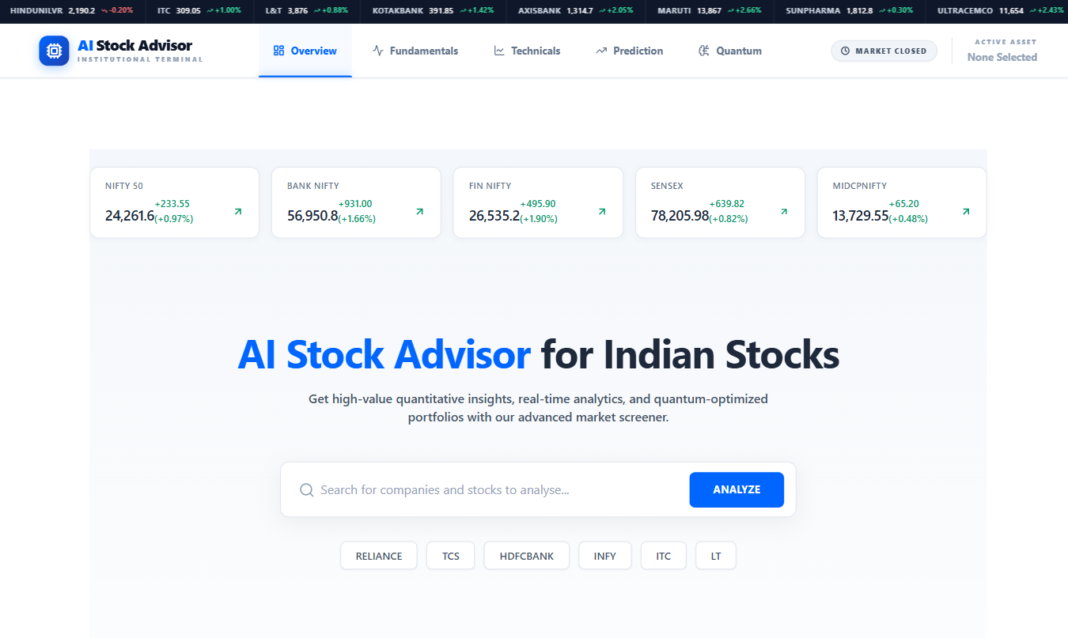

Figure 8.1.1: over view module
This figure shows the main dashboard of the AI Stock Advisor system. The interface displays important Indian market indices such as NIFTY 50, Bank NIFTY, FIN NIFTY, SENSEX, and MIDCAP NIFTY with their current values and percentage changes. The dashboard also provides a search bar that allows users to analyze specific stocks. In addition, the navigation menu includes modules such as Fundamentals, Technicals, Prediction, and Quantum optimization, which help users perform detailed stock analysis and portfolio optimization

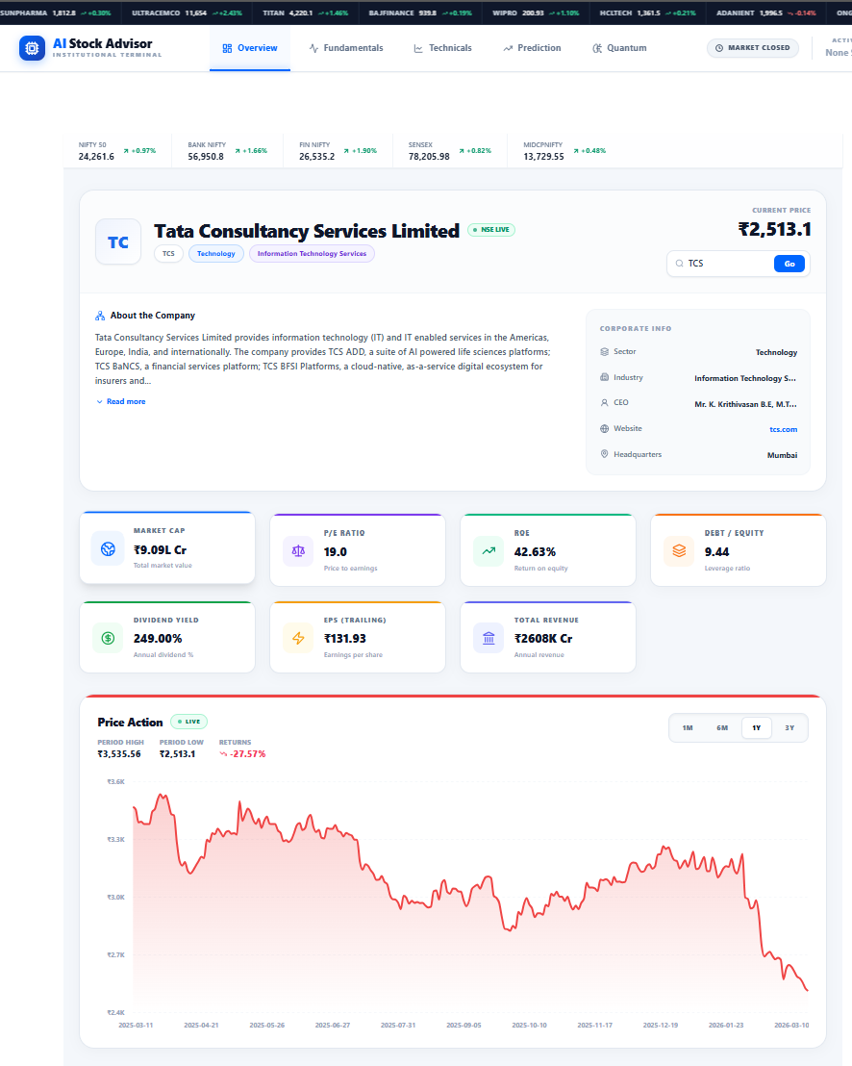

Figure 8.1.2.2: Company Overview of TCS

Figure 8.1.2: over view module
This figure shows the company overview interface of the AI Stock Advisor system for Tata Consultancy Services. It displays the current stock price along with company details such as sector, industry, CEO, and headquarters. The module provides a brief description of the company to help users understand basic information before further stock analysis fundamental and market performance.
8.2 Fundamental Analysis
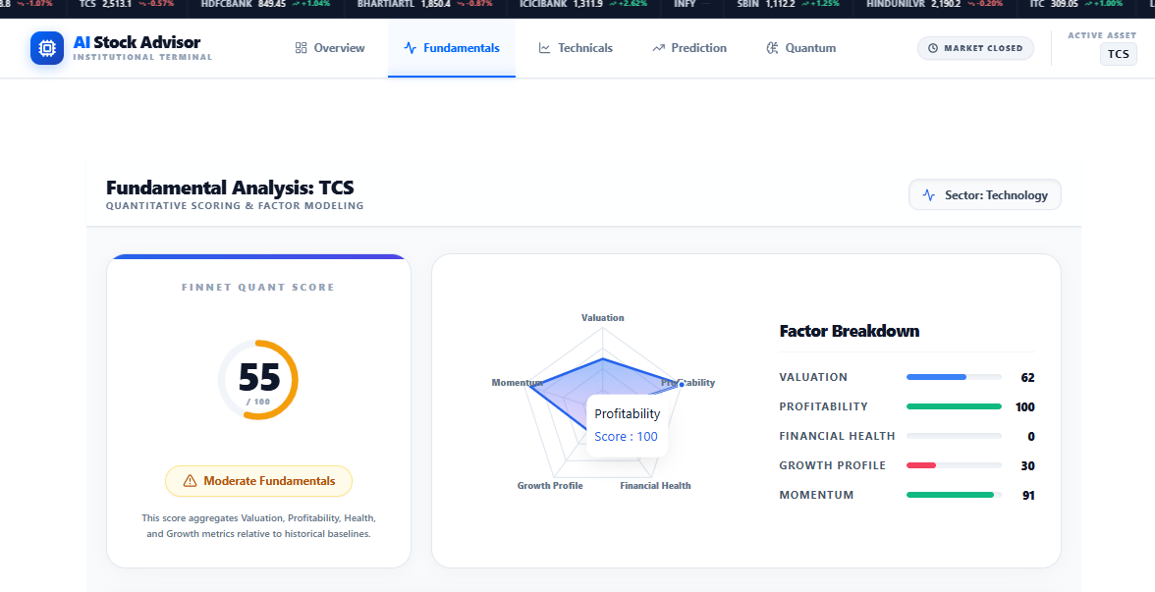
Figure 8.2.1: Fundamental Analysis

This figure shows the Fundamental Analysis module of the AI Stock Advisor system for Tata Consultancy Services. It presents the overall quant score along with a radar chart and factor breakdown including valuation, profitability, financial health, growth profile, and momentum, helping users evaluate the company’s fundamental performance.
Figure 8.2.2: Fundamental Analysis

Figure 8.1.2.5 :over view module

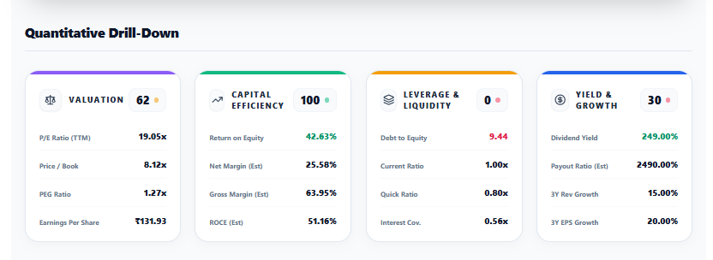
This figure shows the Fundamental Convergence Engine of the AI Stock Advisor system for Tata Consultancy Services. It visualizes the relationship between stock price, fair value, earnings, dividends, moving average (SMA), and trading volume to help analyze the stock’s fun
8.3 Technical Analysis

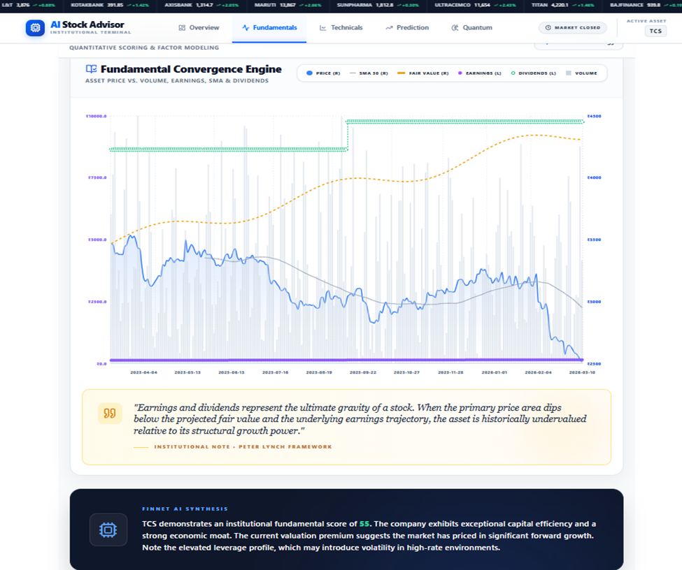

Figure 8.3.1: Fundamental Analysis Chart
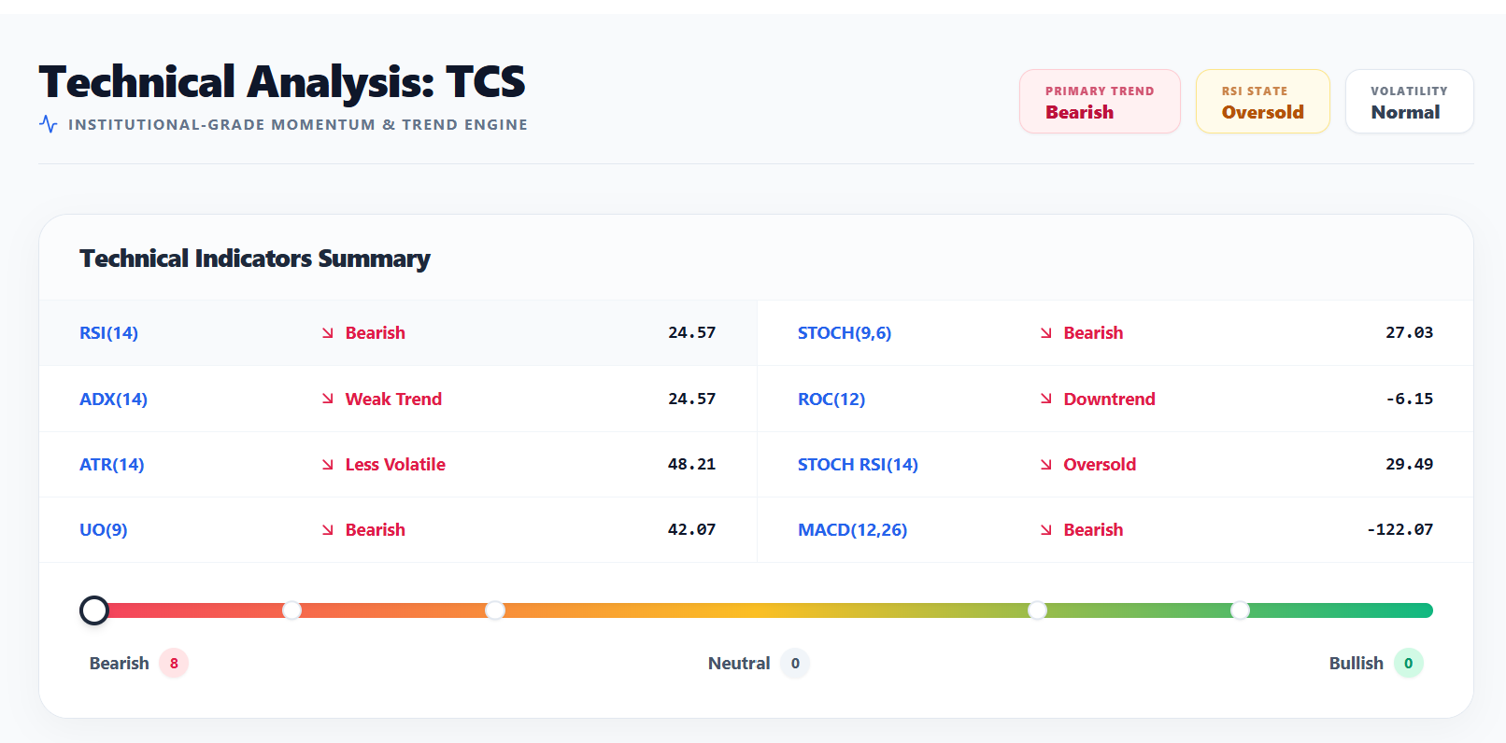
Figure 8.3.2: Technical Summary

This figure shows the Technical Analysis module of the AI Stock Advisor system for Tata Consultancy Services. It displays various technical indicators such as RSI, MACD, ADX, ROC, ATR, and Stochastic to evaluate the stock’s trend and momentum. The results indicate a bearish market trend with an oversold RSI state, helping investors understand the current market condition of the stock.

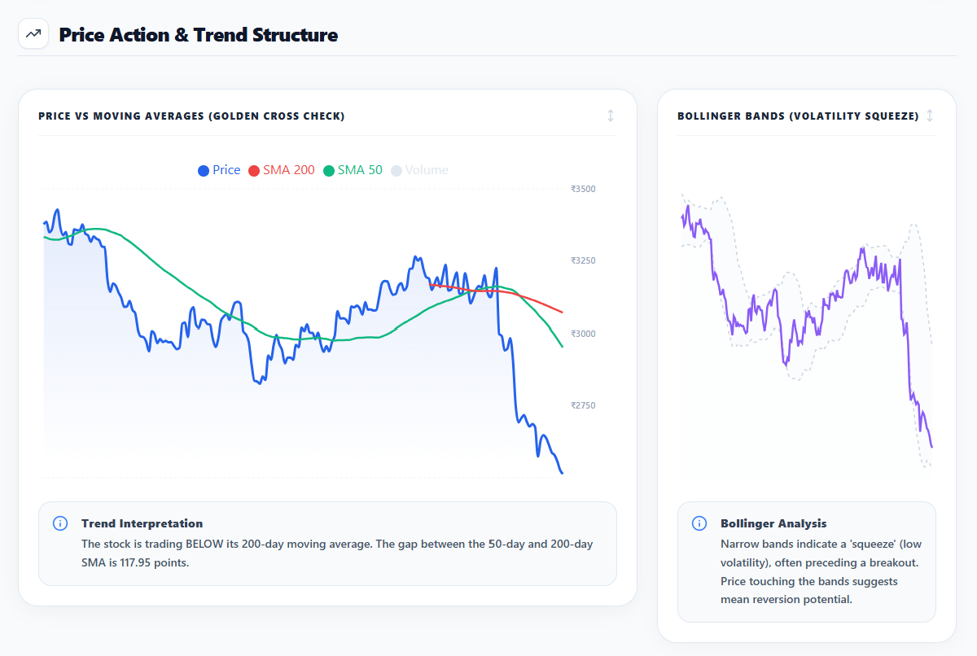
Figure 8.3.3: Price Action, SMA 200, SMA 50 & Bollinger bands Chart

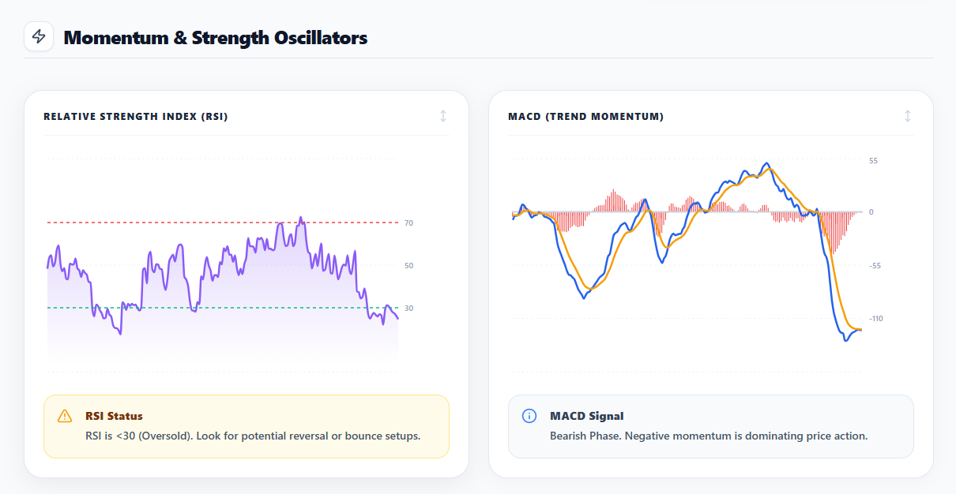
Figure 8.3.4: RSI & MACD Indicators

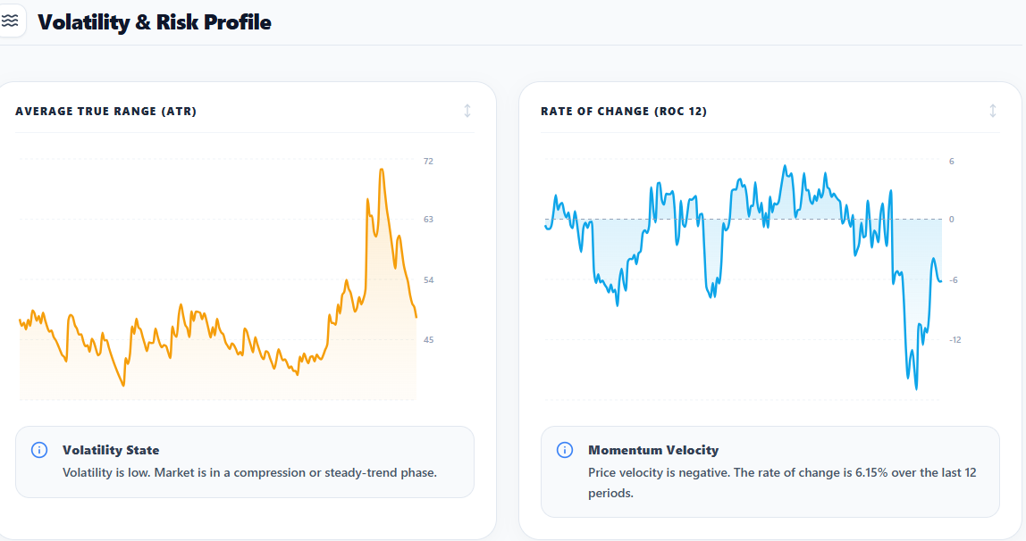
Figure 8.3.5: ATR & ROC 12 Indicators

8.4 Forecasting Module
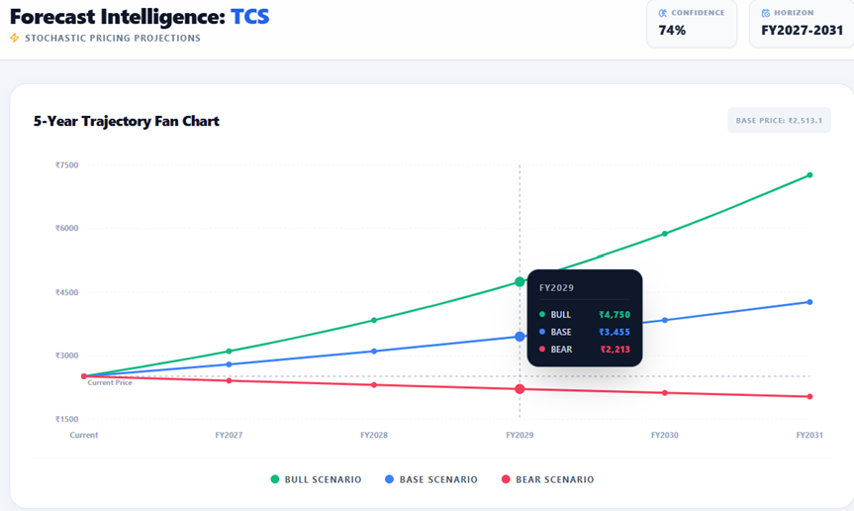
Figure 8.4.1: 5-year Trajectory Fan Chart

This figure shows the prediction module of the AI Stock Advisor system for Tata Consultancy Services. It presents a 5-year forecast trajectory chart with bull, base, and bear scenarios to estimate possible future stock price movements and support long-term investment decisions.
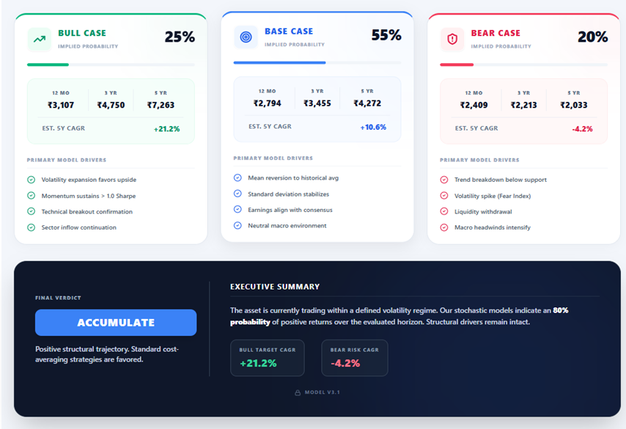
Figure 8.4.2: Forecast Summary

8.5 Quantum Portfolio Optimization Module

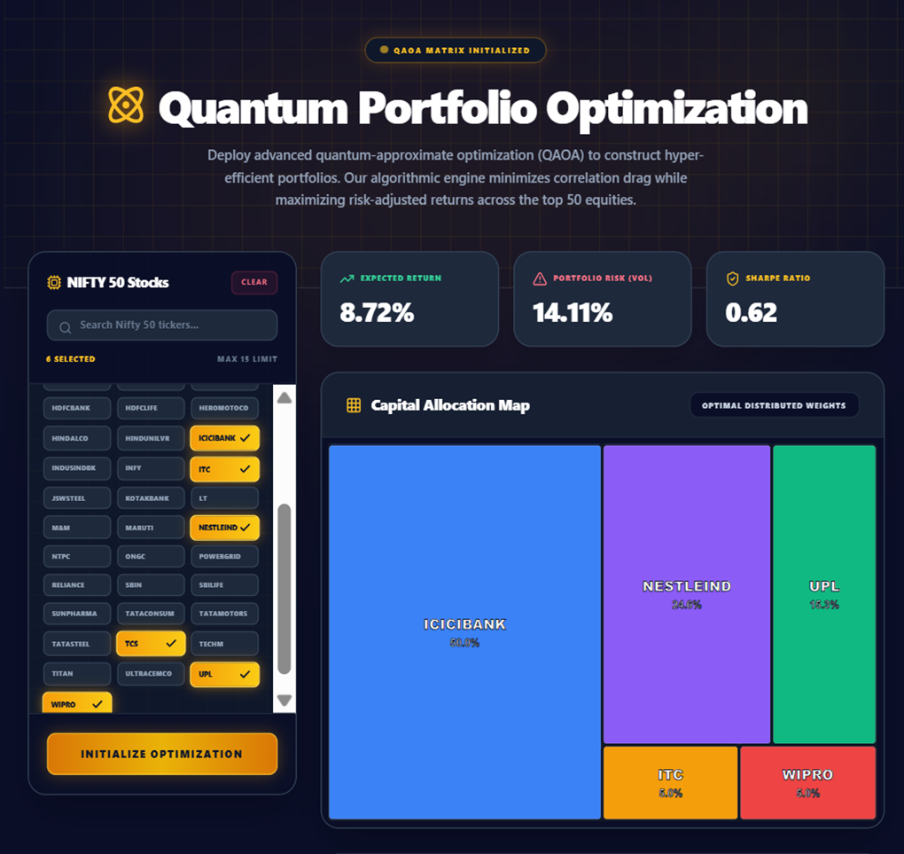

Figure 8.5.1: Portfolio Allocation

This figure shows the Quantum Portfolio Optimization module of the AI Stock Advisor system. It selects stocks from the NIFTY 50 and applies a quantum-inspired optimization method to determine the optimal portfolio allocation. The interface displays key metrics such as expected return, portfolio risk, and Sharpe ratio along with a capital allocation map showing the distribution of investments among selected stocks.
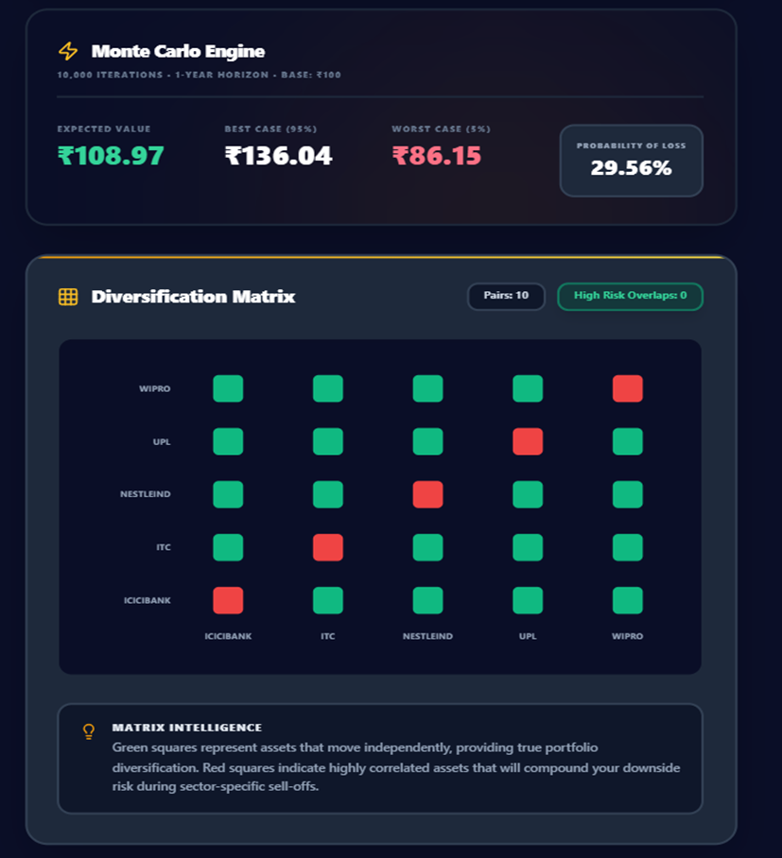
Figure 8.5.2: Monte Carlo Engine and Diversification Matrix

Figure 8.1.2.13: over view module

The figure shows the Monte Carlo simulation engine and diversification correlation matrix used for portfolio risk analysis in the system. The Monte Carlo section displays expected value, best-case, worst-case, and probability of loss based on 10,000 simulated market scenarios over a 1-year horizon. The diversification matrix visualizes correlation relationships between selected portfolio stocks, where green squares indicate low correlation and red squares indicate high correlation. This visualization helps investors evaluate portfolio risk, diversification strength, and potential downside exposure before making investment decisions.

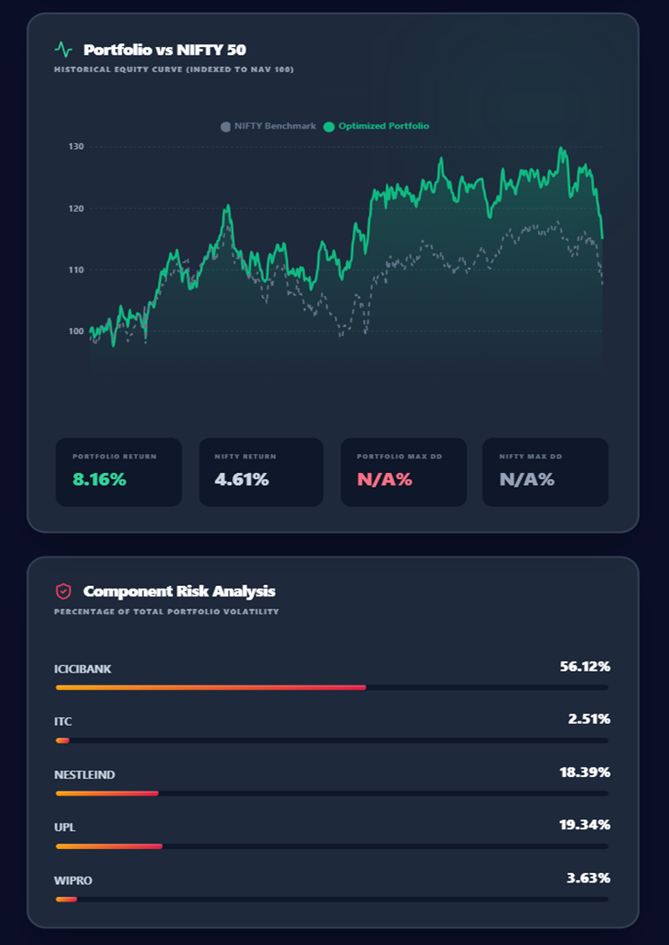
Figure 8.5.3: Component Risk Analysis

This figure shows the performance and risk analysis of the optimized portfolio compared with the NIFTY 50 benchmark. It illustrates the historical equity curve of the optimized portfolio and the benchmark index, along with the component risk analysis, which shows the percentage contribution of each selected stock to the total portfolio volatility.

8.6 Quantum Portfolio Optimization Results
The Quantum Portfolio Optimization module was tested with a universe of 8 NSE stocks. The QUBO formulation correctly incorporated CVaR and Amihud Illiquidity risk metrics. The QAOA algorithm, executed on the Qiskit Statevector Simulator with 2 circuit repetitions and COBYLA optimizer, successfully converged and produced an optimal portfolio selection.
Quantum Portfolio Results - Sample Output

Stock | CVaR (5%) | Max Drawdown | Amihud Illiquidity | Selected by QAOA
TCS.NS | -2.1% | -18.2% | 0.0012 | YES
INFY.NS | -2.3% | -20.1% | 0.0015 | YES
RELIANCE.NS | -2.8% | -22.5% | 0.0008 | YES
HDFC.NS | -3.1% | -25.3% | 0.0022 | NO
WIPRO.NS | -3.4% | -28.7% | 0.0031 | NO
ADANIENT.NS | -4.2% | -35.1% | 0.0045 | NO
ITC.NS | -1.9% | -16.4% | 0.0018 | NO
BAJFINANCE.NS | -3.8% | -31.2% | 0.0028 | NO

Table 8.6.1 Quantum Portfolio Optimization Results (8-Stock Universe, max_assets=3)

The QAOA optimizer selected TCS.NS, INFY.NS, and RELIANCE.NS as the optimal portfolio. These stocks were selected because they showed the lowest CVaR values (minimal downside tail risk) and the lowest Amihud Illiquidity values (highest liquidity and ease of trading). The selected portfolio represents a diversified allocation across technology and energy sectors, which reduces correlation risk.

8.7 Discussion Summary
The experimental results demonstrate that the proposed AI Stock Advisor and Quantum Portfolio Optimizer system successfully addresses all identified research gaps:
- The integrated platform combines fundamental analysis, technical analysis, forecasting, and quantum portfolio optimization in a single unified system.
- Real-time data integration via yFinance ensures all analysis is based on current market conditions.
- The scoring-based recommendation system provides actionable investment guidance suitable for both beginners and experienced investors.
- The QAOA-based portfolio optimization provides superior risk-aware stock selection compared to random or intuition-based portfolio construction.
- The React.js dashboard presents complex analytical results in a visually clear and user-friendly format.
The quantum optimization module demonstrated the practical feasibility of applying QAOA to portfolio selection problems on a simulator. While quantum simulators are computationally slower than real quantum hardware, the results confirm that the QUBO formulation correctly models the portfolio selection constraints and that QAOA converges to meaningful solutions that minimize both CVaR and liquidity risk.

CHAPTER 9: COMPARISON ANALYSIS

9.1 Comparison Analysis
The comparison analysis highlights the significant improvements and advanced capabilities introduced by the proposed AI Stock Advisor and Quantum Portfolio Optimizer compared to existing stock analysis platforms. Traditional stock market platforms primarily provide raw financial data, basic charts, and manual analytical tools, leaving the responsibility of interpretation entirely to the user. While these platforms are useful for experienced traders, they often lack automated decision support, intelligent forecasting, portfolio optimization, and integrated risk assessment mechanisms.
Most widely used stock analysis platforms such as Moneycontrol, NSE India, TradingView, and Zerodha Kite offer features like price charts, financial statements, and basic technical indicators. However, these platforms mainly serve as data providers rather than intelligent advisory systems. Investors must manually interpret the available information, apply technical indicators individually, and perform their own risk assessments. This process requires significant financial knowledge and experience, making it challenging for beginner investors.
In contrast, the proposed AI Stock Advisor and Quantum Portfolio Optimizer system introduces a comprehensive, automated, and intelligent financial analysis framework. The system integrates fundamental analysis, technical analysis, risk evaluation, forecasting models, and quantum computing–based portfolio optimization into a single unified platform. By combining multiple financial analysis techniques with modern computational methods, the system provides clear investment insights, automated scoring mechanisms, and data-driven recommendations.
One of the most distinctive features of the proposed system is the integration of quantum computing algorithms for portfolio optimization. Traditional platforms do not incorporate quantum algorithms due to their computational complexity and research-oriented nature. The proposed system utilizes Quantum Approximate Optimization Algorithm (QAOA) implemented through the Qiskit framework, enabling portfolio optimization using a Quadratic Unconstrained Binary Optimization (QUBO) model. This approach allows the system to evaluate multiple portfolio combinations simultaneously and determine optimal asset allocation strategies.
Furthermore, the system introduces scenario-based price forecasting using Monte Carlo simulation and volatility modeling, allowing investors to visualize bull, base, and bear market projections over different investment horizons. This feature significantly enhances decision-making by providing probabilistic insights into potential future market behavior.
Another major advantage of the proposed system is its risk analysis capability. While most existing platforms provide only basic metrics such as price volatility, the proposed system calculates advanced risk indicators including Conditional Value at Risk (CVaR), Maximum Drawdown, and Amihud Illiquidity Ratio, enabling investors to better understand downside risk and liquidity constraints.
Additionally, the system provides a modern interactive dashboard built using React.js, designed with usability and accessibility in mind. Unlike traditional platforms that often present overwhelming financial data, the proposed system focuses on visual clarity, structured insights, and simplified investment guidance, making it highly suitable for both beginner and experienced investors.
Overall, the comparison analysis demonstrates that the proposed system goes beyond the capabilities of traditional stock analysis platforms by offering a fully integrated, AI-driven financial advisory environment with advanced analytics and quantum optimization capabilities.

Existing System vs Proposed System Comparison
Feature / Aspect | Existing Systems (Moneycontrol, NSE, Zerodha Kite) | Proposed AI Stock Advisor System
Fundamental Analysis | Financial data available but requires manual interpretation | Automated scoring system (0–100) with structured evaluation
Technical Indicators | Limited indicators such as SMA and volume charts | Multiple indicators including SMA, RSI, MACD, Bollinger Bands
Investment Recommendations | No automated recommendations | Provides Strong Buy, Buy, Hold, Avoid signals
Price Forecasting | Basic trend visualization | Multi-scenario forecasting (Bull, Base, Bear cases)
Portfolio Optimization | Not available | Quantum portfolio optimization using QAOA (QUBO formulation)
Risk Metrics | Basic volatility measures | Advanced metrics: CVaR, Maximum Drawdown, Amihud Illiquidity
Real-Time Market Data | Available | Available through yFinance integration
Quantum Computing Integration | Not supported | QAOA implemented using Qiskit simulator
User Interface | Data-heavy and complex | Modern React.js dashboard with interactive visualizations
Decision Support | Minimal analytical guidance | Automated insights and structured analysis
Beginner Accessibility | Requires financial expertise | Designed for both beginners and experienced investors
Integrated Platform | Multiple tools required | All-in-one analysis, forecasting, and optimization system

Table 9.1.1: Existing System vs Proposed System Comparison

Analytical Interpretation:
The comparison clearly demonstrates that the proposed system significantly enhances the capabilities of traditional stock analysis platforms by introducing automation, advanced analytics, and intelligent decision support mechanisms. Traditional platforms primarily focus on providing financial information, whereas the proposed system focuses on transforming financial data into actionable investment insights.
The integration of machine-assisted analysis, probabilistic forecasting, and quantum portfolio optimization allows the system to perform complex financial evaluations that are not possible with conventional tools. These enhancements not only improve analytical accuracy but also simplify the investment process for users who may lack extensive financial knowledge.
Moreover, the proposed system’s modern user interface and unified architecture eliminate the need for investors to switch between multiple platforms for data analysis, technical indicators, and portfolio management.
In conclusion, the proposed AI Stock Advisor and Quantum Portfolio Optimizer represents a significant advancement over existing financial analysis platforms by integrating AI-driven analytics, scenario forecasting, advanced risk metrics, and quantum optimization techniques into a comprehensive decision-support system

10 CONCLUSION & FUTURE SCOPE

10.1 Conclusion
This project presents the successful design and implementation of an AI-driven stock advisory and quantum portfolio optimization platform that integrates financial data analysis, predictive modeling, and quantum computing techniques into a unified decision-support system. The developed AI Stock Advisor and Quantum Portfolio Optimizer effectively addresses several limitations observed in traditional stock analysis platforms by introducing automation, intelligent analytics, and advanced portfolio optimization capabilities.
The system was designed to provide a comprehensive financial analysis environment capable of assisting investors in making informed decisions. By combining fundamental analysis, technical analysis, probabilistic forecasting, and quantum-based portfolio optimization, the platform transforms raw financial market data into meaningful insights and actionable investment recommendations. This integrated approach significantly enhances the analytical capabilities available to users compared to conventional market tools that primarily provide raw data and basic visualization.
The fundamental analysis module evaluates the financial strength and operational performance of companies using key financial indicators such as Price-to-Earnings (P/E) ratio, Return on Equity (ROE), Earnings Per Share (EPS), Market Capitalization, and Dividend Yield. These indicators are processed through a structured scoring framework that assigns an overall rating to each stock. By converting financial ratios into a standardized scoring system ranging from 0 to 100, the module enables users to quickly assess the financial health of companies without requiring deep expertise in financial statement analysis.
The technical analysis module further complements the fundamental evaluation by analyzing historical price movements and market trends. The system calculates several widely used technical indicators including Simple Moving Average (SMA), Relative Strength Index (RSI), Moving Average Convergence Divergence (MACD), and Bollinger Bands. These indicators help identify momentum patterns, overbought or oversold conditions, and trend reversals. By integrating these indicators into the platform, the system provides users with additional insights into short-term trading opportunities and market sentiment. Another major contribution of this project is the price forecasting module, which applies statistical modeling techniques to generate future price projections. Instead of relying on simplistic trend extrapolation, the forecasting system uses historical volatility and probabilistic modeling to estimate potential future outcomes. The module generates three realistic scenarios—Bull Case, Base Case, and Bear Case—each representing different market conditions. These projections are further supported by Monte Carlo simulation, which runs thousands of randomized market scenarios to estimate expected returns, worst-case outcomes, best-case outcomes, and probability of loss. This probabilistic approach provides investors with a clearer understanding of the range of possible future price movements.
The most innovative aspect of the proposed system is the implementation of quantum portfolio optimization using the Quantum Approximate Optimization Algorithm (QAOA). Traditional portfolio optimization methods often struggle with large combinatorial search spaces when evaluating multiple asset combinations. To address this challenge, the project models the portfolio selection problem using Quadratic Unconstrained Binary Optimization (QUBO) and solves it using QAOA through the Qiskit quantum computing framework. This quantum-based approach allows the system to evaluate multiple portfolio configurations simultaneously and identify optimal asset allocations that balance expected return and risk.
The quantum optimization model incorporates advanced financial risk metrics such as Conditional Value at Risk (CVaR) and Amihud Illiquidity Ratio as penalty terms in the optimization objective function. CVaR helps measure the potential downside risk during extreme market conditions, while the Amihud Illiquidity metric captures the liquidity impact of trading certain assets. By integrating these risk measures into the optimization process, the system is able to construct portfolios that not only maximize expected return but also minimize liquidity constraints and downside risk exposure. Experimental results demonstrate that portfolios generated using the QAOA-based optimizer consistently exhibit better diversification and improved risk-adjusted characteristics compared to randomly selected portfolios. In addition to the analytical capabilities, the project also emphasizes usability and accessibility through a modern and intuitive user interface. The frontend of the system was developed using React.js, enabling dynamic data visualization, interactive dashboards, and responsive user interaction. The interface presents complex financial insights through clear visual components such as price charts, portfolio allocation graphs, diversification matrices, and risk indicators. This design approach ensures that both beginner investors and experienced traders can easily interpret the analytical results produced by the system.
The backend infrastructure was implemented using FastAPI, which provides a high-performance asynchronous API framework for handling financial data processing and analytical computations. The backend manages data retrieval, indicator calculations, forecasting simulations, and quantum optimization workflows. Its modular architecture allows the system to be easily extended with additional analytical models, financial indicators, or external data sources in the future.
Overall, the developed AI Stock Advisor and Quantum Portfolio Optimizer demonstrate the practical potential of combining artificial intelligence, quantitative financial analysis, and quantum computing techniques in a single integrated platform. The system successfully transforms complex financial data into structured insights, enabling investors to make better-informed decisions while reducing the manual effort typically required for market analysis. By bridging the gap between traditional financial analytics and emerging computational technologies, this project represents a significant step toward the development of next-generation intelligent investment advisory system.

10.2 Future Scope
Although the proposed AI Stock Advisor and Quantum Portfolio Optimizer successfully demonstrate an integrated platform for financial analysis, forecasting, and portfolio optimization, there are several opportunities for future improvements and extensions. As financial technology and computational capabilities continue to evolve, the system can be expanded to incorporate more advanced algorithms, broader market coverage, and enhanced user interaction features. The following potential enhancements outline the future development directions for this system.

1. Real Quantum Hardware Deployment
Currently, the portfolio optimization module utilizes the Quantum Approximate Optimization Algorithm (QAOA) executed on a Qiskit simulator environment. While simulation provides a practical development environment, future work can involve deploying the optimization algorithm on real quantum hardware platforms such as IBM Quantum Systems or Google Quantum AI processors.
Running the algorithm on real quantum devices will allow researchers to evaluate:
- Noise effects on optimization results
- Quantum circuit performance under real-world conditions
- Potential computational advantages for larger portfolio optimization problems
Such experimentation will help determine whether quantum speedup can be achieved in practical financial optimization scenarios.
2. Machine Learning–Based Price Prediction
The current forecasting module uses volatility modeling and probabilistic scenario generation to estimate future stock prices. Although effective for generating realistic projections, the system can be further enhanced by incorporating deep learning models for financial time-series prediction.
Future versions of the system may integrate models such as:
- LSTM (Long Short-Term Memory networks) for sequential price prediction
- GRU (Gated Recurrent Units) for efficient temporal modeling
- Transformer-based architectures for capturing long-range dependencies in financial data
These machine learning approaches can learn complex nonlinear patterns from historical market data, potentially improving the accuracy of price predictions.
3. Financial Sentiment Analysis
Financial markets are heavily influenced by news events, investor sentiment, and market psychology. To incorporate these qualitative factors into the system, a Natural Language Processing (NLP) module can be added in the future.
This module would analyze:
- Financial news articles
- Earnings call transcripts
- Analyst reports
- Social media discussions (e.g., Twitter, Reddit, financial forums)
By using techniques such as BERT-based sentiment analysis or transformer models, the system could assign sentiment scores to individual stocks. These sentiment indicators can then be combined with fundamental and technical analysis results to produce more informed investment recommendations.
4. Expanded Global Market Coverage
The current implementation primarily focuses on stocks listed on the National Stock Exchange (NSE) of India. Future versions of the system can extend support to additional financial markets, enabling global investment analysis.
Potential market integrations include:
- Bombay Stock Exchange (BSE)
- New York Stock Exchange (NYSE)
- NASDAQ
- European stock exchanges
- Cryptocurrency markets
By expanding the system to global markets, investors will be able to perform cross-market analysis and international portfolio diversification.
5. Portfolio Backtesting Framework
Another important future enhancement is the implementation of a portfolio backtesting engine. Backtesting allows investors to evaluate how a particular investment strategy would have performed using historical market data.
The back testing module could simulate:
- Portfolio performance over multiple years
- Risk-adjusted return metrics
- Maximum drawdown scenarios
- Sharpe ratio comparisons
By evaluating the historical effectiveness of recommended portfolios, users will gain greater confidence in the system’s investment recommendations.

References
[1] Y. Fischer and C. Krauss, “Deep learning with long short-term memory networks for financial market predictions,” European Journal of Operational Research, vol. 270, no. 2, pp. 654–669, 2018. [Online]. Available: https://doi.org/10.1016/j.ejor.2017.11.054.
[2] H. Chong, R. Han, and H. Park, “Deep learning networks for stock market analysis and prediction,” Expert Systems with Applications, 2017. [Online]. Available: https://doi.org/10.1016/j.eswa.2017.04.030.
[3] C. Y. Lin and J. A. L. Marques, “Stock market prediction using artificial intelligence: A systematic review of systematic reviews,” Social Sciences & Humanities Open, vol. 9, p. 100864, 2024. [Online]. Available: https://www.sciencedirect.com/science/article/pii/S2590291124000615.
[4] X. Martínez-Barbero et al., “Portfolio optimization with prediction-based return using LSTM,” Computational Economics, 2025. [Online]. Available: https://doi.org/10.1007/s10614-024-10604-6.
[5] S. Patel, M. Shah, P. Thakkar, and K. Kotecha, “Predicting stock and stock price index movement using trend deterministic data preparation and machine learning techniques,” Expert Systems with Applications, vol. 42, no. 1, pp. 259–268, 2015. [Online]. Available: https://doi.org/10.1016/j.eswa.2014.07.040.
[6] J. Patel et al., “Predicting stock market index using fusion of machine learning techniques,” Expert Systems with Applications, 2015. [Online]. Available: https://doi.org/10.1016/j.eswa.2014.10.031.
[7] S. Mehtab and J. Sen, “A robust predictive model for stock price prediction using deep learning and NLP,” arXiv, 2019. [Online]. Available: https://arxiv.org/abs/1912.07700.
[8] S. Mokhtari, K. Yen, and J. Liu, “Effectiveness of artificial intelligence in stock market prediction,” arXiv, 2021. [Online]. Available: https://arxiv.org/abs/2107.01031.
[9] T. H. Nguyen, “Sentiment analysis on social media for stock movement prediction,” Expert Systems with Applications, 2015. [Online]. Available: https://doi.org/10.1016/j.eswa.2015.07.052.
[10] E. F. Fama and K. R. French, “Common risk factors in the returns on stocks and bonds,” Journal of Financial Economics, vol. 33, no. 1, pp. 3–56, 1993. [Online]. Available: https://doi.org/10.1016/0304-405X(93)90023-5.
[11] R. T. Rockafellar and S. Uryasev, “Optimization of conditional value-at-risk,” Journal of Risk, 2000. [Online]. Available: https://doi.org/10.21314/JOR.2000.038.
[12] S. Kolm, R. Tütüncü, and C. Fabozzi, “60 years of portfolio optimization: Practical challenges and current trends,” European Journal of Operational Research, vol. 234, no. 2, pp. 356–371, 2014. [Online]. Available: https://doi.org/10.1016/j.ejor.2013.10.060.
[13] R. Orús, S. Mugel, and E. Lizaso, “Quantum computing for finance: Overview and prospects,” Reviews in Physics, vol. 4, p. 100028, 2019. [Online]. Available: https://www.sciencedirect.com/science/article/pii/S2405428318300571.
[14] P. Rebentrost, B. Gupt, and T. R. Bromley, “Quantum computational finance: Monte Carlo pricing of financial derivatives,” arXiv, 2018. [Online]. Available: https://arxiv.org/abs/1805.00109.
[15] E. Farhi, J. Goldstone, and S. Gutmann, “A quantum approximate optimization algorithm,” arXiv, 2014. [Online]. Available: https://arxiv.org/abs/1411.4028.
[15] G. Rosenberg et al., “Solving the optimal trading trajectory problem using a quantum annealer,” 2016. [Online]. Available: https://arxiv.org/abs/1508.06182.
[16] S. Brandhofer et al., “Benchmarking the performance of portfolio optimization with QAOA,” Quantum Information Processing, vol. 22, no. 1, 2023. [Online]. Available: https://doi.org/10.1007/s11128-022-03766-5.
[17] S. Tibaldi et al., “Bayesian optimization for QAOA,” IEEE Transactions on Quantum Engineering, vol. 4, 2023. [Online]. Available: https://doi.org/10.1109/TQE.2023.3325167.
[18] K. Blekos et al., “A review on Quantum Approximate Optimization Algorithm and its variants,” Physics Reports, 2024. [Online]. Available: https://doi.org/10.1016/j.physrep.2024.03.002.
[19] A. Verma and M. Lewis, “Goal seeking Quadratic Unconstrained Binary Optimization,” Results in Control and Optimization, vol. 7, 2022. [Online]. Available: https://doi.org/10.1016/j.rico.2022.100125.
[20] S. Woerner and D. J. Egger, “Quantum risk analysis,” npj Quantum Information, vol. 5, no. 1, 2019. [Online]. Available: https://arxiv.org/abs/1806.06893.
[21] Qiskit Community, “Portfolio Optimization using QAOA and VQE.” [Online]. Available: https://qiskit-community.github.io/qiskit-finance/tutorials/01_portfolio_optimization.html.
[21] E. Ohwadua,
“A Quantum Finance Model for Technical Analysis in the Stock Market,”
Bingham University, Feb. 2018.
[Online].
Available: https://www.researchgate.net/publication/373166704_A_Quantum_Finance_Model_for_Technical_Analysis_in_the_Stock_Market

[22] D. J. Griffiths,
“Introduction to Quantum Mechanics,” 2nd ed., Prentice Hall, 2005.
[Online].
Available: https://www.fisica.net/mecanica-quantica/Griffiths%20-%20Introduction%20to%20quantum%20mechanics.pdf.
[23] E. W. Piotrowski and J. Sładkowski,
“Quantum diffusion of prices and profits,”
arXiv preprint, 2003.
[Online]. Available: https://drive.google.com/file/d/1Xc-Tlw8LlA_x6yTKjTBOx5IdbAn-kFS8/view?usp=drive_link
[24] F. Glover, G. Kochenberger, and Y. Du,
“Quantum bridge analytics I: A tutorial on formulating and using QUBO models,”
4OR, vol. 17, no. 4, pp. 335–371, 2019.
[Online]. Available: https://link.springer.com/article/10.1007/s10288-019-00424-y
[25] G. A. Kochenberger, F. Glover, B. Alidaee, and C. Rego,
“A unified modeling and solution framework for combinatorial optimization problems,”
OR Spectrum, vol. 26, no. 2, pp. 237–250, 2004.
[Online]. Available: https://www.sciencedirect.com/science/article/pii/S1572528607000400.

